**Propose Algorithm: Improved Cluster-Head Selection Algorithm for Mobile Ad-Hoc Networks**

**Behrang Sharafi1, Valiollah Panahizadeh2*, Amir Refahi Oskouei3.**

Department of Mechanical Engineering, Shahid Rajaee Teacher Training University, Tehran, Iran.

*P.O.B. 16785-163 Tehran, Iran, [v.panahizadeh@sru.ac.ir](mailto:v.panahizadeh@sru.ac.ir)

**Abstract**

In this paper, we have briefly mentioned some of the clustering algorithms and divided them into multiple types based on the Cluster Head (CH) selection criteria in the Mobile Ad-Hoc networks, so we introduce an efficient distributed clustering algorithm in the Ad-hoc network that ideally maintains the transmission ability, mobility and power supply ability of manageable nodes by a Cluster-Head. The proposed algorithm, based on the nodes mobility, performed adaptively and the process of CHs selection delayed as much as possible to reduce the computational costs. Finally, using simulated experiments, we have shown the proposed algorithm or Improved Cluster-Head Selection Algorithm (ICHSA), in terms of the reconnecting loops and updating the nodes set that are associate by the selected improved cluster-head, has a better condition than the existing similar algorithms.

**Key words**

*Ad-Hoc, ICHSA, Clustering, Cluster-Head, Node.*

**1. INTRODUCTION**

The Mobile Ad Hoc Network (MANET) is a collection of two or more devices or nodes or terminals with wireless communications and networking capability that communicate with each other without the aid of any centralized administrator or wireless nodes that can dynamically form a network to exchange information without using any existing fixed network infrastructure [1]-[3].

In general, the wireless computer topologies are divided into Infrastructure and Ad-Hoc networks. In the Infrastructure, a central device called Access Point, as an interconnect point is used but in the Ad-Hoc topology, a peripheral device is not used and each computer is somehow in the role of an Access Point.

The Mobile Ad-Hoc network is a distributed, autonomous and self-organized system and consists of many small sensor nodes (SN) which operate with a low-energy condition [4]-[6].

The sensor nodes have limitations in energy sources, processing and calculations. To manage these dense and distributed networks, the challenges such as scalability, damage tolerance, stability and efficient solutions for energy consumption are need to be noted [7]-[9].

The clustering is one of the most efficient techniques that is used to solving these challenges at Mobile Ad-Hoc networks. This technique is widely used in network management for connectivity, coverage and lifetime optimization; whereby, a group of sensor nodes forms a cluster where nodes communicate with each other and send their sensed data to a pivotal node called CH. There are different types of clustering: static or dynamic, single or multi-hop, and homogeneous or heterogeneous. The nodes in the cluster are classified into a cluster master node known as CH, and other cluster sensor nodes known as SNs. Each cluster contains at least one CH, and it is responsible for gathering data from all the clusters’ SNs [10]-[11]. According to the dynamic nature of mobile nodes, their connection or dis connection from cluster, disrupt the network stability. Therefore, the re-configuring of CHs are inevitable. The CH changes, include the timing, route design and resource allocation have a negative effect on the performance of other related protocols [12].

Several algorithms have been proposed for selecting the CH in the Ad-Hoc network. In some of these algorithms, the node that has a highest degree select as the CH. One of the losses of this method is that, there is no limitation for the maximum quantity of nodes per each cluster which affects on the operational capability and cluster stability strongly [10], [13].

Some of the algorithms assign a unique identifier (ID) to each node and select a node with the lowest ID as the CH. Despite the strong desire of these nodes, for selection constantly as a CH, the battery discharges these nodes quickly. This method has a better operational capability than the mentioned methods which choose a node with the highest degree as the CH [14]-[16].

The Distributed Motion Adaptive Clustering Algorithm (DMAC), is one of the clustering algorithms based on the node competency to become a CH. This algorithm allocates a real number greater or equal to zero to every node. The updates that are needs for this algorithm are less than other algorithms with the highest and lowest IDs, but in this approach, choosing a CH is very costly and there is no improvement in the system parameters such as the throughput and power control [17]-[18].

Another algorithm based on the clustering is Weighted Clustering Algorithm (WCA) that the CHs are selected based on a weight that is allocated to the nodes [6], [8]. In such a way, the defined weight in this algorithm is calculated for all nodes from a cluster and then a node with the least individual weight is selected as the CH [19]-[21].

WCA-GA and WCA-SA are another algorithm based on the clustering technique their consumption energy amount are the least in each clustering process [22]-[24]. Combination of the WCA and genetic algorithms (GA) lead to the WCA-GA algorithm and combination of the WCA and simulated annealing algorithm (SA) has made the WCA-SA algorithm.

In these two approaches, instead of the weight calculation for all of the nodes, the weight is calculated just for the initial population that has been introduced in the algorithm. In such way, less energy has been consumed in each clustering. In the other hand among all of the mentioned algorithms, the WCA eventuate the improved CH selection better than others do [25].

In this paper, we have proposed a clustering algorithm in the Ad-Hoc networks which in addition to managing the energy consumption and electing the improved CHs, can manage the number of times that an algorithm has been run and traffic balance of this algorithm is better than the other clustering algorithms in the Ad-Hoc networks.

We have named this algorithm as, Improved CH Selection Algorithm and in short, we call it ICHSA.

**2. THE CH SELECTION PROCESS IN PROPOSE ALGORITHM**

A network of nodes and edges can be represented by an undirected simple graph G = (V, E) where V is the set of nodes (vi) and E is the set of edges (ei). Note that the members of V do not change, but the members of E always change by creating and deleting the edges.

The clustering can be considered as a graph-partitioning problem along with a series of additional constraints. Since this graph does not show any regular structure, fall under the category of NP-hard problems. The solutions for these problems are generally derived using approximate heuristic algorithms that explaining of them is not possible here [12-13]. In other words, we are looking for the set of vertices S, which are a subset of V (G), so can say:

$$∪_{v∈s}N\left[v\right]=V\left(G\right) \left(1\right)$$

In this equation, $N\left[v\right]$ is a neighborhood of the node $v$. S is the set of vertices and $V\left(G\right)$ is the set of nodes in $S$ belong to the graph G. The neighborhood of a CH is a set of nodes located within its transmission domain. If each vertex G belongs to S or has a neighbor in it, the set $S$ is called the improved set of CHs.

In general, this equation says that, from the union of nodes set that are in the neighbourhood of S-member nodes, the member nodes of graph G are obtained.

**3.** **THE STEPS OF CH SELECTION**

The CH selection process consists of eight steps as follows:

**Step 1.** Finding the neighbours of each node $v$, i.e., the nodes are in the transmission domain of a node. This action help us to define $d_{v}$ (the node degree). So by equation (2):

$$d_{v}=\left|N(v)\right|=\sum_{v^{'}∈N(v),v^{'}≠v}{\left[dist(v,v^{'})\right]} <tx_{range}\left(2\right)$$

Where $\left|N(v)\right|$ means the magnitude of $N(v)$, $x_{range}$ is the radius of transmission domain, t is the number of neighbor nodes and $dist(v,v^{'})$ is distance between the nodes $v$ and $v^{'}$. Note that the sum of distances among $v$ and other nodes should be lower than $t×x_{range}$.

**Step 2.** Calculating the degree-difference, $∆_{v},$ for every node $v$ which is equivalent to: $∆_{v}=d_{v}-δ$ and $δ=\left|\sum_{v^{'}∈N(v),v^{'}≠v}{\left[dist(v,v^{'})\right]}-tx_{range}\right|$

**Step 3.**Calculating $D_{v}$ or the summation of distances among every node and its neighbor nodes*, so using equation (3):*

$$D_{v}=\sum_{v^{'}∈N(v)}{[dist(v,v^{'})}] \left(3\right)$$

Which, $dist(v,v^{'})$ is distsnce between every two nodes $vϵS$ and $v^{'}ϵN(v)$. Note, the difference between $d_{v}$ and $D_{v}$ is that, $d_{v}$ should be smaller than $tx_{range}$ but for $D_{v}$ there is no such requirement.

**Step 4**. Calculating the movement average speed for each node $v$, up to time T that during it, the node $v$ acts as a CH. This value gives us a scale of motion and show with $M_{v}$. See چنequation 4.

$$M_{v}=\frac{1}{T}\sum_{t=1}^{T}{\sqrt{{\left(X_{t}-X_{t-1}\right)}^{2}+{\left(Y_{t}-Y_{t-1}\right)}^{2}}} \left(4\right)$$

In this equation ($X_{t},Y_{t}$) and ($X_{t-1},Y_{t-1}$) are geometric coordinates of the node $v$ at time t and t-1.

**Step 5**. Now we need to find $E_{Have,B}$ from equation 5, which represents the total amount of allocated energy to the sensor battery.

$$P_{Have}=\frac{E_{Have}}{T*β} \left(5\right)$$

In this equation $P_{Have}$ is the energy consumption rate (consumable power) from battery by the nodes. T is the time that, during it, the node $v$ acts as a CH and β is reduction of the battery consumption rate based on the time T. Should note the value of β for the CH nodes is more than the value of it for the Non-CH nodes. This difference is based on this belief the CH nodes have more traffic than the commonplace nodes, so they have more energy consumption.

The equation 5 shows the nodes gradually lose their energy. On the other hand, equation 6 shows how we can find the consumable energy in each node $v$ that is a function of time. Thus:

$$P_{v}=P_{Have}\left(t-1\right)-P_{Have}\left(t\right) \left(6\right)$$

**Step 6**. Local optimization for each node

In equation 7, the coefficients $w_{1}, w_{2}, w_{3},w_{4} and w_{5}$ are associated with the optimal clustering function:

${∀Δ_{v}≠0 =≫ w}_{v}=\frac{w_{1}Δ_{v}×w_{5}P_{Have,v}}{w_{2}D_{V}+w_{3}M_{V}+w_{4}P_{v}} , ∀Δ_{v}=0=≫ w_{v} =\frac{w_{1}δ×w_{5}P_{Have,v}}{w_{2}D_{V}+w_{3}M_{V}+w_{4}P_{v}} \left(7\right)$

The third component of ${ W}_{v}$ is due to the nodes mobility in the clustering. A node with a less mobility is always a better choice for CH node and $Δ_{v}$ is the degree of CH node that might be negative, zero or positive number. Now we should specify $D_{V}$, i.e., the average distance of each node from neighboring nodes that are one-step away from it.

The purpose of $D_{V}$ detection is mainly related to the energy consumption, because more energy is needed to communicate with a farther node. Hence, by equation 8:

$$D_{V}=\frac{1}{n}\sum_{j=1}^{n}{Dis(i,j)} , Dis(i,j)=\sqrt{{(X_{i}-X_{j})}^{2}+{(Y_{i}-Y_{j})}^{2}}\left(8\right)$$

Where $Dis(i,j)$, shows the distance between each pair of adjacent nodes. Note that the continuous weakening of signal power is inversely proportional to a power of distance. Now, using equation 9:

$$ClusterHead_{Select}=Max\left(w_{v}\right) \left(9\right)$$

Which $'ClusterHead_{Select}'$ shows the conditions that, a node is selected as the CH.

**Step 7.** Select the CH according to the maximum value of $W_{v}$. None of the neighbours of selected CH is allowed to participate at the CH selection process

**Step 8**. Repeat the steps 2 to 7, for every one of the remained nodes that have not been selected for the CH or have not been assigned to a cluster yet.

Surely, the nodes of Ad-Hoc networks for transmission of every data use the routing technique. The clustering process is run in a distributed form, i.e., every time a cluster is re-clustered, all of the nodes compute the mobility of their selves and transfer it to the neighbour nodes. This work will be continue to find a node with the highest ${ W}_{v}$ that is the most suitable node for CH.

**4. WORKING PROCEDURE**

The working procedure of OCHS Algorithm has the following steps:

*4.1. Checking the nodes of a cluster at the static status*

This state applies only for a cluster node that the $w_{v}$ value (mobility) of its CH, reaches to zero or desired threshold. The mobility can be related to the cluster members or the CH members.

If the mobility is relevant to the nodes which do not have a single-step-distance from the CH node, the mobility ($w_{v}$) of CH will change at a lower rate. Therefore, the cluster structure is stable and we can count on it. Nevertheless, if the mobile nodes are the ones that locate at a single-step-distance from the CH, the CH degree will change and $∆_{v}$ can has the negative or positive values.

When the $∆_{v}$ is negative, the $w_{v}$ amount is negative too, the cluster structure is cluttered and re-clustering process should be done. Nevertheless, when $∆_{v}$ is positive, the cluster is stable still and there is no need for re-clustering.

According to these explanations, we have implemented the following steps for the cluster nodes at the static status:

4.1.1. Calculating the distance of nodes from each other (the distance of a node from single-step neighbors and according to the node degree).

4.1.2. Calculating the energy amount is used to sending each packet (according to the energy consumption equation).

4.1.3. Calculating the number of single-step neighbors for every one of the nodes (the purpose is the degree of each node).

*4.2. The periodic study of energy in the CH-node*

The period of CH selection is a function of time, for example, in the OCHS algorithm, the CH node according to its degree, calculates $w_{v}$ periodically and once a minute. So:

4.2.1. Run the nodes status algorithm on the clusters to find the CHs, when the energy of CHs reaches to the suitable threshold.

*4.3. Investigating the mobility status of Non-CH nodes*

4.3.1. Using the computational function for detection the node average distance from the single-step nodes

4.3.2. If the distance of a node from the cluster-node is minimum, this node will be one of the desired cluster members.

*4.4. Investigating the mobility of CH-node*

4.4.1. If the CH mobility affects on the node degree (the number of neighbour nodes), run the clustering algorithm for the whole cluster again.

4.4.2. If the CH mobility doesn’t affect on the node degree, no operation will be performed and the CH node is stable (for improvement of the CH selection process in the algorithm).

4.4.3. If the mobility of nodes improves the degree and mobility of CH node, run the clustering operation.

*4.5. Re-clustering the algorithm by minimizing the distance of CH node from the single-step neighbour nodes, i.e.:*

4.5.1. Calculate the degree of each node. (Equation 6).

4.5.2. Calculate the average distance of each node from the one-step nodes.

If the average distances of a node from other nodes (non-member adjacent nodes in a cluster) were equal, the energy parameter of neighbour nodes for members is calculated and used, separately. (Equation 5).

4.5.3. The competency of each node, for being a CH, is investigated according to its one-step neighbours. Then the best node is selected for CHs.

4.5.4. From the existent nodes, all of the nodes which are the members of new cluster would be deleted.

4.5.5. The clustering process continues until all of the nodes will be a cluster or CH member.

4.5.6. If a node is out of the radio range of other nodes, it will be left out from the network completely.

**5. RUNNING THE ALGORITHM**

The schematic of proposed OCHS algorithm as a Mobile Ad-Hoc network by using the genetic algorithm is shown in Figure 1 to 5.

If you note to these figures, will find out the running process of this algorithm easily.

As shown in the Figure 1, we run our algorithm on 15 nodes. The algorithm output values of these nodes are listed in Table **1**.

**TABLE 1** Output Values from the OCHS Algorithm

|  |  |  |  |  |  |  |
| --- | --- | --- | --- | --- | --- | --- |
| Node  ID | $d_{V}$ $Step 1$ | $Δ_{v}$ $Step 2$ | $D_{V}$ $Step 3$ | $M_{V}$ $Step 4$ | $P_{V}$ $Step 5$ | $W_{V}$ $Step 6$ |
| 1 | 2 | 0 | 6 | 2 | 1 | 1.35 |
| 2 | 1 | 1 | 4 | 2 | 2 | 1.70 |
| 3 | 1 | 1 | 3 | 3 | 1 | 1.50 |
| 4 | 1 | 1 | 3 | 4 | 2 | 1.60 |
| 5 | 3 | 1 | 9 | 1 | 4 | 2.75 |
| 6 | 1 | 1 | 3 | 2 | 2 | 1.50 |
| 7 | 2 | 0 | 6 | 0 | 0 | 1.20 |
| 8 | 2 | 0 | 7 | 3 | 3 | 1.70 |
| 9 | 4 | 2 | 13 | 2 | 6 | 4.40 |
| 10 | 3 | 1 | 12 | 2 | 7 | 3.35 |
| 11 | 1 | 1 | 3 | 0 | 1 | 1.35 |
| 12 | 2 | 0 | 5 | 3 | 4 | 1.35 |
| 13 | 2 | 0 | 7 | 3 | 2 | 1.65 |
| 14  15 | 2  1 | 0  1 | 5  3 | 2  4 | 0  3 | 1.10  1.65 |
|  |  |  |  |  |  |  |

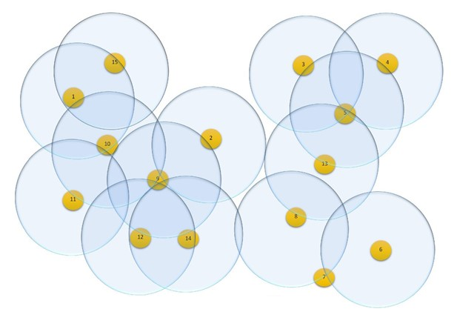

**Fig.1**. Initial configurations of nodes.

Figure 1, shows the initial configuration of the network’s nodes with a unique ID, for every one of the nodes. The circles with the equal radius show a constant transmission domain for each node. A node can receive the traffic signals from the nodes which are in the transmission domain of it. A line between two nodes means that they are neighbour together. Figure 2, shows the neighbours’ detection by the network nodes.

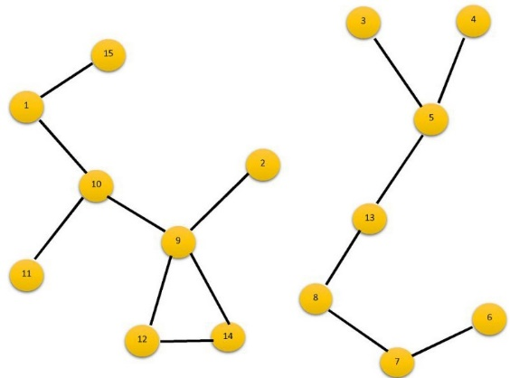

**Fig.2**. Neighbors detection.

The arrows which are shown in Figure 3, specify the speed and direction of nodes mobility. The longest arrow means the most mobility and the shortest arrow means the least mobility.

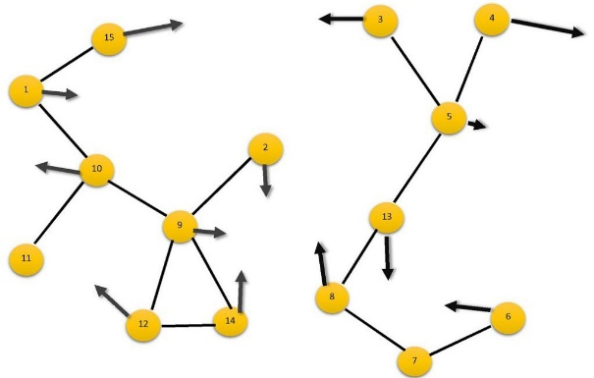

**Fig.3**. Nodes speed.

Figure 4, shows that how a node with at least $w_{v}$, is elected as the CH (after running the OCHS clustering algorithm). The black nodes show the selected CHs for the network. Note that every two CHs aren't necessarily neighbour to each other directly.

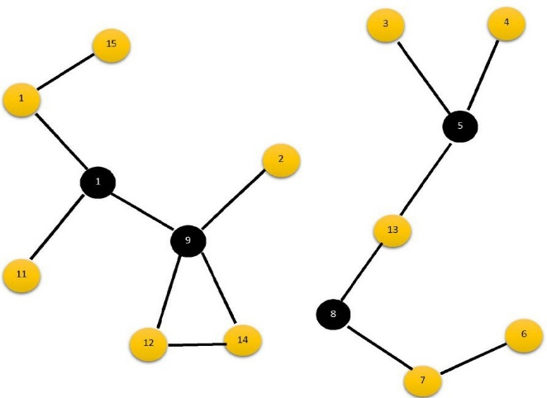

**Fig.4.** Clusters-head diagnosis.

In Figure 5, we see that by algorithm's running, the initial CHs are formed. It is seeing that the total number of neighbours, which are managed by each CH, are close to the ideal predetermined degree in the proposed algorithm (δ = 2). In this figure, the links obtained from the network are seen clearly. In this case, a single-component graph is obtained, i.e., there is a path from one node to any other node.

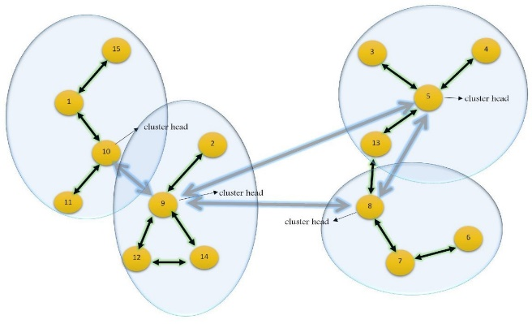

**Fig.5**. Clusters diagnosis.

**6. EVALUATION**

At the first, from the 50 to 100 nodes, the clustering process is evaluated in terms of the Ad-Hoc nodes members. For each configuration, 10 nodes are selected randomly. The simulation process is created using the group mobility model, based on the equation 5, we run our algorithm on 10 different random speeds and for every one of them. We have compared the output data of proposed OCHS algorithm with the WCA-SA, WCA and WCA-GA algorithms statistically in figures 6 to 10. The position data for all of the selected 10 nodes are equal on the graph.

Figure 6, shows the average period of CHs to change the number of nodes in the simulation process. The experiments have been done with 10 different mobility speed that in them d = 5, r = 100 and time = 1000s. The curve of OCHS algorithm in the figure 6, shows the longer periods of CHs.

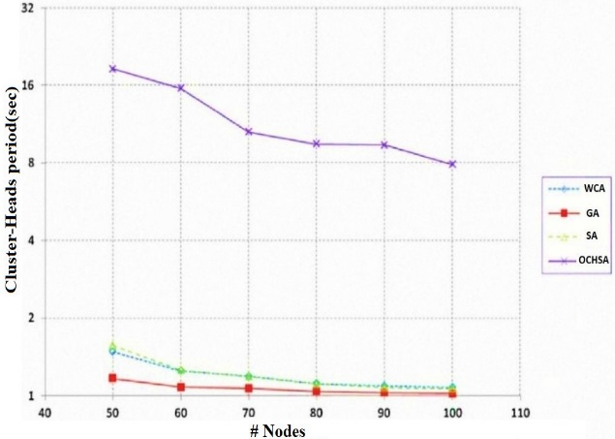

**Fig.6.** CHs period and the number of nodes.

Figure 7, shows the maximum communication of CHs on average, at each stage of simulation and for all implemented experiments on the algorithms (WCA, SA, GA and OCHS). According to the equation 3, the curves of this Fig show that the OCHS algorithm generates the least traffic for the CHs.

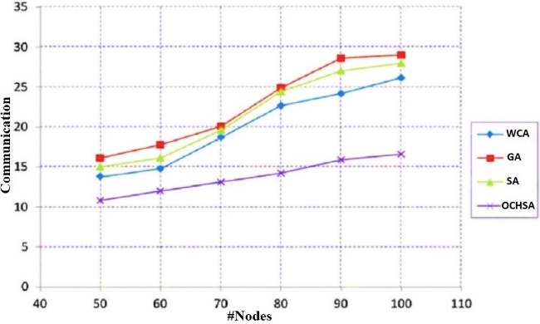

**Fig.7.** Communications and the number of nodes.

The curves in figure 8, show the period average of CHs for change the group of selected nodes. The simulation has been done for different scenarios, with N = 50, $r={100}_{km}$ d = 5, and $time={1000}_{s}$. You can see in this figure; the CHs of OCHS algorithm have the longest periods.

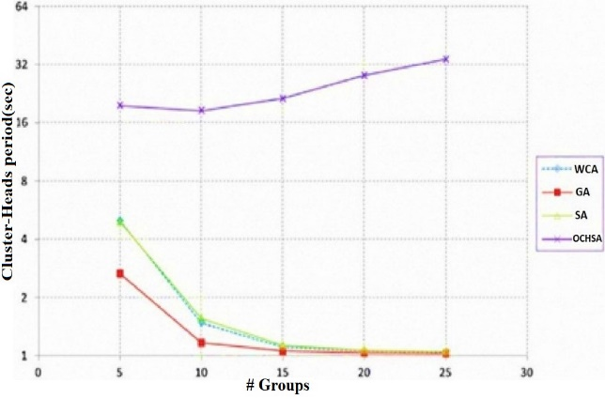

**Fig.8.** CH period and the number of groups.

Figure 9, shows the maximum connection of CHs in the algorithms. This figure shows the proposed OCHS algorithm make the lowest communication traffic in the CHs.

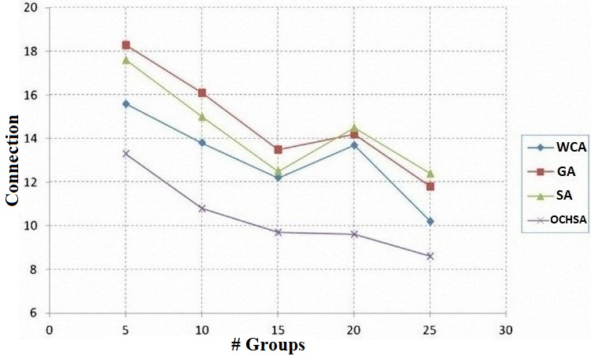

**Fig.9.** Connection and the number of groups.

The results of Figure 10, indicate that in our algorithm, whatever the transmission radius is larger, the average period of CHs is more than the other algorithms.

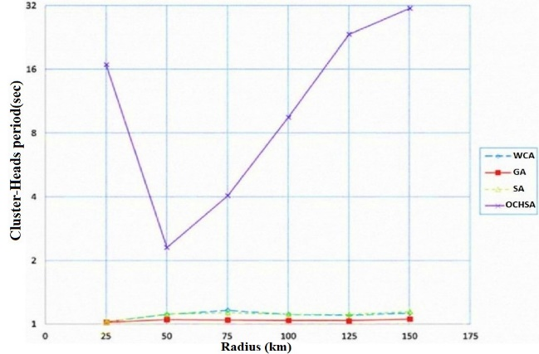

**Fig.10.** CH period and transmission radius.

The curves in Figure 11, show the maximum communication of CHs to change the nodes transmission radius of simulation. The results of this curves show that whatever the nodes transmission radius is larger, the communication traffic of OCHS algorithm, compared to others, will have been less.

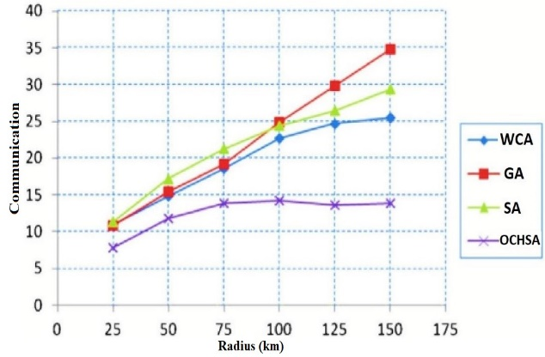

**Fig.11.** Communication and transmission radius.

Figure 12, shows the dead nodes of WCA, SA, GA and OCHS algorithms. The horizontal axis shows the run time of simulations and the vertical axis which shows the dead nodes, is calculated by equation 10.

$$\frac{X}{10}×50 \left(10\right)$$

Where, X is the number of dead nodes and 50 is the number of require nodes for the simulation. As shown in the Fig 12, after completing the simulation time, the number of live nodes in the proposed OCHS algorithm are more than the other clustering algorithms.

These subjects reflect the superiority of proposed simulation algorithm than the other algorithms too.

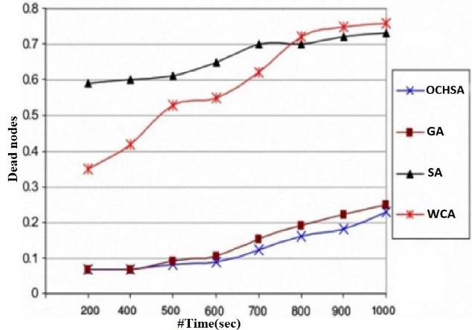

**Fig.12.** Comparison of the dead nodes in the OCHS algorithm with the GA, SA and WCA algorithms.

**7. CONCLUSIONS**

In this paper, we have investigated the work traffic of cluster nodes members and additional work traffic of CH nodes in the mobile Ad-Hoc network.

The simulation results show that the Improved CH Selection Algorithm or ICHSA, has a great potential at dealing with the mobile Ad-Hoc networks and can by an improved management of energy and power consumption, increases the lifetime of mobile Ad-Hoc network.

In the simulation process, we also considered 10 different scenarios for different speeds of nodes, which complicated the analysing process of algorithms for selecting and managing CHs.

After reviewing the results, we conclude that the designed algorithms for the fixed topologies of Ad-Hoc networks, even if by evolutionary algorithms have been stronger and more intelligent, in some cases, may can't be able to improve the Ad-Hoc networks status.

But the proposed algorithm in this paper (ICHSA), based on the distributed calculation method, and could improve the clustering and CH selection processes greatly. This improvement is consisted of the communication levels, algorithm loops, re-clustering and fitness function evaluation for choosing the CHs.

This research did not receive any specific grant from funding agencies in the public, commercial or not-for-profit sectors.

**8. REFERENCES**

[1] Jeong, Cheol, and Won Yong Shin. “HierHybNET: Capacity Scaling of Ad Hoc Networks with Cost-Effective Infrastructure.” *Ad Hoc Networks* 37 (2016): 543–552.

[2] Yin, Zhanping, and Victor C.M. Leung. “Performance Improvements of Integrating Ad Hoc Operations into Infrastructure IEEE 802.11 Wireless Local Area Networks.” *Computer* Saha, Sujoy et al. “Designing Delay Constrained Hybrid Ad Hoc Network Infrastructure for Post-Disaster Communication.” *Ad Hoc Networks* 25. PB (2015): 406–429.

[3] Safwat, Ahmed, and Hossam Hassanein. “Infrastructure-Based Routing in Wireless Mobile Ad Hoc Networks.” *Computer Communications* 25.3 (2002): 210–224.

[4] Plößl, Klaus, and Hannes Federrath. “A Privacy Aware and Efficient Security Infrastructure for Vehicular Ad Hoc Networks.” *Computer Standards and Interfaces* 30.6 (2008): 390–397.

[5] Ngo, Chi Trung, and Hoon Oh. “TLSR: A Tree Link State Routing Protocol Using Message Aggregation Based on a Skewed Wait Time Assignment for Infrastructure-Based Mobile Ad Hoc Networks.” *Computer Communications* 74 (2016): 87–100.

[6] Hassanein, Hossam, Tiantong You, and Hussein T. Mouftah. “Infrastructure-Based MAC in Wireless Mobile Ad-Hoc Networks.” *Ad Hoc Networks* 3.6 (2005): 717–743.

[7] Gómez Mármol, Félix, and Gregorio Martínez Pérez. “TRIP, a Trust and Reputation Infrastructure-Based Proposal for Vehicular Ad Hoc Networks.” *Journal of Network and Computer Applications* 35.3 (2012): 934–941.

[8] Familiar, Miguel S. et al. “Building Service-Oriented Smart Infrastructures over Wireless Ad Hoc Sensor Networks: A Middleware Perspective.” *Computer Networks* 56.4 (2012): 1303–1328.

[9] Baraka, Kim et al. “An Infrastructure-Aided Cooperative Spectrum Sensing Scheme for Vehicular Ad Hoc Networks.” *Ad Hoc Networks* 25.PA (2015): 197–212.

[10] Zhang, Ying, and Hongliang Sun. “A Clustered Routing Protocol for Underwater Wireless Sensor Networks.” *Chinese Control Conference, CCC*. Vol. 2015-September. 2015.

[11] Corn, J., and J. W. Bruce. “Clustering Algorithm for Improved Network Lifetime of Mobile Wireless Sensor Networks.” *2017 International Conference on Computing, Networking and Communications, ICNC 2017*. 2017.

[12] Lee, Ickjai, and Jianhua Yang. “Common Clustering Algorithms.” *Comprehensive Chemometrics*. Elsevier, 2020. 531–564.

[13] Tyagi, Sudhanshu, and Neeraj Kumar. “A Systematic Review on Clustering and Routing Techniques Based upon LEACH Protocol for Wireless Sensor Networks.” *Journal of Network and Computer Applications* Mar. 2013: 623–645.

[14]Raval, Gaurang, Madhuri Bhavsar, and Nitin Patel. “Analyzing the Performance of Centralized Clustering Techniques for Realistic Wireless Sensor Network Topologies.” *Procedia Computer Science*. Vol. 57. Elsevier, 2015. 1026–1035.

[15] Randhawa, Sukhchandan, and Sushma Jain. “MLBC: Multi-Objective Load Balancing Clustering Technique in Wireless Sensor Networks.” *Applied Soft Computing Journal* 74 (2019): 66–89.

[16]Ramluckun, Natasha, and Vandana Bassoo. “Energy-Efficient Chain-Cluster Based Intelligent Routing Technique for Wireless Sensor Networks.” *Applied Computing and Informatics* (2020): n. pag.

[17] Zhang, Yan, Jim Mee Ng, and Chor Ping Low. “A Distributed Group Mobility Adaptive Clustering Algorithm for Mobile Ad Hoc Networks.” *Computer Communications* 32.1 (2009): 189–202.

[18]Nguyen, Minh Tuan. “Distributed Compressive and Collaborative Sensing Data Collection in Mobile Sensor Networks.” *Internet of Things* 9 (2020): 100156.

[19]Ouchitachen, Hicham, Abdellatif Hair, and Najlae Idrissi. “Improved Multi-Objective Weighted Clustering Algorithm in Wireless Sensor Network.” *Egyptian Informatics Journal* 18.1 (2017): 45–54.

[20]Aissa, Mohamed, Abdelfettah Belghith, and Khalil Drira. “New Strategies and Extensions in Weighted Clustering Algorithms for Mobile Ad Hoc Networks.” *Procedia Computer Science*. Vol. 19. Elsevier B.V., 2013. 297–304.

[21]Li, Jierui et al. “Stepwise Genetic Algorithm for Adaptive Management: Application to Air Quality Monitoring Network Optimization.” *Atmospheric Environment* 215 (2019): n. pag.

[22]Zachariasa, C. R., M. R. Lemes, and A. Dal Pino. “Combining Genetic Algorithm and Simulated Annealing: A Molecular Geometry Optimization Study.” *Journal of Molecular Structure: THEOCHEM* 430.1–3 (1998): 29–39.

[23]Mohammadi, Mahmoud, Mahin Nastaran, and Alireza Sahebgharani. “Development, Application, and Comparison of Hybrid Meta-Heuristics for Urban Land-Use Allocation Optimization: Tabu Search, Genetic, GRASP, and Simulated Annealing Algorithms.” *Computers, Environment and Urban Systems* 60 (2016): 23–36.

[24]Fu, Yingjie et al. “WCA: A Weighting Local Search for Constrained Combinatorial Test Optimization.” *Information and Software Technology* 122 (2020): n. pag.

[25]Chen, Shi Ming, Ali Sarosh, and Yun Feng Dong. “Simulated Annealing Based Artificial Bee Colony Algorithm for Global Numerical Optimization.” *Applied Mathematics and Computation* 219.8 (2012): 3575–3589.