|  |
| --- |
| **Some Reflections on Architectural Projects Seeking for Spatial Emancipation**  Babak Ashtari 1, Mansour Yeganeh 2   1. PhD Candidate, Department of Architecture, Tarbiat Modares University, Tehran, Iran 2. Assistant Professor, Department of Architecture, Tarbiat Modares University, Tehran, Iran |
|  |
|  |
| *Corresponding Author: Babak1980.architect@gmail.com |

**Abstract**

*Spatial emancipation can be considered as an architectural meta-project, namely, endeavors have made by designers to overcome traditional boundaries of space so as to achieve much more continuity and fluidity in architectural space. Although these efforts has long lasting history, after modern period thanks to the remarkable advancement in technology regarding structure of the buildings, significant architectural projects has been developed in line with this general approach. Nonetheless, reflection on these projects and their contribution to spatial emancipation as a general approach and interrelation of these projects in a historical evolutionary process has remained disregarded. Thus, this qualitative documentary study tried to bring forward significant architectural projects after modern period each of which obtain a significant achievement in liberating space from imposed traditional boundaries and also cast a light on their interrelations in a historical evolutionary process. The required data has been collected by literature survey and document analysis and the collected data has been analyzed through descriptive-analytic method. The findings illustrated that, Free Plan accompanying with Open Plan, Free Section and boundless space are three major architectural projects which not only has significant contribution to spatial emancipation as a general approach, but also there is a meaningful and didactic interrelations between them in a historical evolutionary process.*

**Keywords:**

*Spatial Emancipation, Architectural Project, Free plan, Free section, Boundless Space*

1. **Introduction**

Space is indisputably the focal point of any architectural endeavors, ethereal essence which influence body and mind.One of the major issues for architects has been seeking for methods enable them to overcome more and more the imposed boundaries of space. These boundaries can be counted as any obstacles which disturb the continuity of space as a result of demanded structural and environmental considerations. Typically, these obstacles demonstrated themselves as limiter vertical or horizontal layers, normally seen as walls, ceiling or even the floor slabs. The more advancement in building construction technology achieved, the more architects could get rid of these obstacles.

It has been an enduring anxiety to achieve spatial emancipation in architectural records. Architects in every epoch endeavored to exploit latest techniques to overcome existed obstacles. For instance in Gothic architecture, as a result of employment of skeletal stone structures, the ratio of mass to void in cathedrals is far less than Romanesque or Byzantine cathedrals. It was therefore the advancement of technology which played a crucial role in design of weightless tall Gothic churches with extensive internal void, which can be noticed as a great achievement in liberating the space through reducing the mass of buildings.

This search for achieving more emancipation through reducing the material features of architecture on the side of its spatial continuity has been noticed even as a general approach throughout architectural history. According to Mirmiran (1996), deep analysis illustrates common link between all great achievements in architecture. "In general, global architecture features a process of evolution that has taken place over a thousands of years. This process is a movement from material state to spiritual state; in architectural term, reduction in material and expansion of space."

Yet, with the rise of modern movement, particularly in the twentieth century thanks to the utilization of steel and concrete skeleton, architects found more opportunities to maneuver through this approach and to develop significant architectural projects, each of which tried to eliminate the limiter of space whether as vertical or horizontal layers. At first, for the sake of clarification it is necessary to explain what the exact aspired meaning of architectural project is for this paper.

* 1. **The notion of Architectural Project**

Humankind is inevitably dealing with space in every aspect of his life. There is a reciprocal relationship between human and space; they impact each other or let's say, they shape each other. Architecture as a certain discipline which its main agenda is to providing a suitable space for living, indisputably has a potential to affect the space not only environmentally but also socially, economically and politically. Yet the main issue is how architecture can attain its potential.

One of the most informative argument in this regard has been put forward by Eisenman as he distinguished between architectural project and architectural practice and argued: "architectural project involves the discipline of architecture in some ways; that is a discipline being able to define the world and being able to be a critical response or resonance on that definition." (Eisenman, 2013)

Accordingly, project is an intellectual pursuit carried out as a critical meta-narrative that may engage the world at large, but is articulated in a manner to address architects with an epistemological stake in the field. Thus, the architect’s project should resist and avoid consumption by the normative constraints of the profession, whereas Practice engages projects that are so overdetermined. (Manack, 2016; see also Allen, 1999)

The main point is that any architectural project is always act as a critic of status quo, thus it should be ideological and intellectual. Ergo, it is involved with theory. From this standpoint, architecture enables certain ways of thinking that are "irreducible to other modes of thought". As hay maintained: "While any theory that talks about architecture only—that does not relate architecture to the larger social, material field—is practically useless, at the same time any theory that does not articulate the concrete specificity and semi-autonomy of architecture’s codes and operations misses a major medium of social practice". (Hays, 1998, pp. i-xii)

Moreover, architectural project is the outcome of the zeitgeist; it favors the advances and challenges the boundaries. Hence, it has the capability to push the borders of the discipline. Some architect, typically those who have engaged in theoretical aspect as well as practical, have developed several projects throughout their career. Yet, some other pursue same project for the whole of their profession. That is to say, architectural project does not relate to particular building or any kind of commission. Besides, it does not indicate the ideas or concept of the particular building; maybe several works of an architect developed as the same project but with different ideas and concepts. Architectural Project is more related to the intellectual endeavors transcends beyond certain building or commissioned work and its objective is to challenge the major issues of the discipline.

* 1. **Problem statement, Objective and Methodology**

Spatial emancipation can be considered as architectural meta-project, namely, endeavors have made by designers to overcome traditional boundaries of space so as to achieve much more continuity and fluidity in architectural space. This general approach includes noticeable contributions throughout the history. Yet, after modern period thanks to the remarkable advancement in technology regarding structure of the buildings, significant architectural projects has been developed in line with this general approach. Although certain studies somehow addressed these projects separately, nevertheless reflection on these projects and their contributions to spatial emancipation as a general approach and interrelation of these projects in a historical evolutionary process has remained relatively disregarded.

Thus, considering the spatial emancipation as a general approach, the main objectives of this qualitative documentary study are first, addressing the significant architectural projects since modern period which have contribution to this approach and second, shedding a light on their interrelations in a historical evolutionary process. In view of the aims of this research, required data has been collected by literature survey and document analysis and then collected data has been analyzed through descriptive-analytic method.

1. **Architectural Projects seeking for Spatial Emancipation**
   1. **Free Plan Project**

The term ‘Free Plan’ undoubtedly reminds the name of the master of modern architecture, to wit Le Corbusier. He had a long-lasting ambition to liberate the space from its traditional boundaries. This can be traced conspicuously through his massive oeuvre even his primary works. Indeed he was the man of his time who had profoundly perceived zeitgeist. Short term apprenticeship at the Auguste Perret's office, who was the pioneer of reinforced concrete and a brief experience at Peter Behrens' practice, forming his long-life admiration for concrete. By subtle utilization of advances in construction technology, namely reinforced concrete skeleton, in 1914 he proposed his famous diagram for Maison Dom-Ino (domus being Latin for house, and ino evoking innovation). (Curtis, 1996)

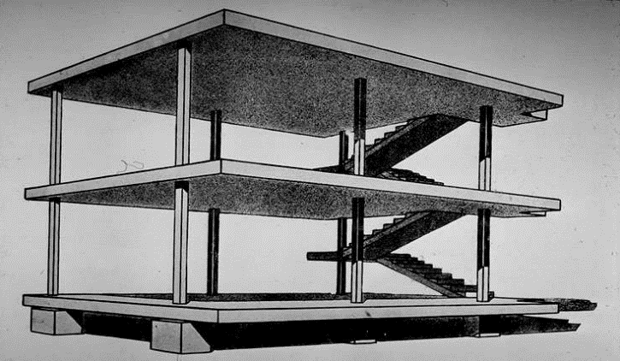

**Fig 1.** Maison Dom-Ino Digram. (Curtis, 1986)

The Idea of Dom-Ino structure was developed as part of mass-produced housing in reinforced concrete for reconstruction of villages in northern France. This innovative diagram comprised three rectangular horizontal slabs, six slender columns supporting each of the upper two slabs and six blocks at the bottom as pedestals, and stairs as connection between slabs.The essential feature of the Maison Dom-Ino which broadly recognized as the icon of modern architecture was the complete independence between the structure (reinforced concrete skeleton) and the other building elements such as walls or windows.

In 1926 Le Corbusier articulated a set of architectural principles based on his extensive practices, which he termed *"Five Points for a New Architecture".* Among these five points, certainly the most critical one for Le Corbusier was the Free Plan. The notion of plan has always been a critical issue for Corbusier. As he wrote in Towards a New Architecture: "Mass and surface are elements by which architecture manifests itself. Mass and surface are determined by the plan. The plan is the generator... The plan carries in itself the very essence of sensation. …A Plan calls for the most active imagination. It calls for the most severe discipline also. The plan is what determines everything; it is the decisive moment". (Le Corbusier, 1923, pp. 47-48)

Although in 1920s Corbusier implemented his points in several domestic houses which critics usually refers them as white villas, yet undoubtedly it was the famous villa Savoye at Poissy (1929–1931) in which Corbusier objectified his essential five points.

**Tabel 1.** Le Corbusier's *Five Points for a New Architecture*. (Developed by authors)

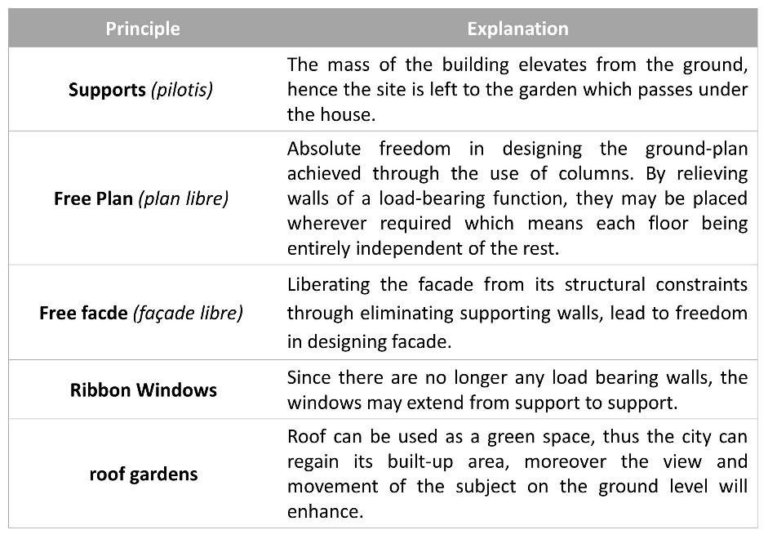

The mass of this iconic building is elevated from the ground, supported by pilotis; the whole façade enjoys strips of ribbon windows and the roof acts as a domestic garden. Yet it also has specific element, namely a ramp rising from ground level to the third floor roof terrace and providing particular continuous circulation throughout the villa. In fact, for Corbusier circulation is a modern practice of efficiency modeled on the automobile. The Villa Savoye can be seen as an outcome of his canon pertaining to circulation. As Benton (2007) pointed, the spatial flow of the building, being organized around the ever-climbing promenade orients and directs through the space. These elements, along with Le Corbusier’s balance of dynamic and rectilinear elements brings a specific character to the building. In this villa, the ramp winds from the entrance up to the salon, a formal interior space that flows seamlessly into the roof terrace outside and it finally culminates in the curved solarium crowning the house, whose rounded enclosure appears to be an abstract sculpture when viewed from below.

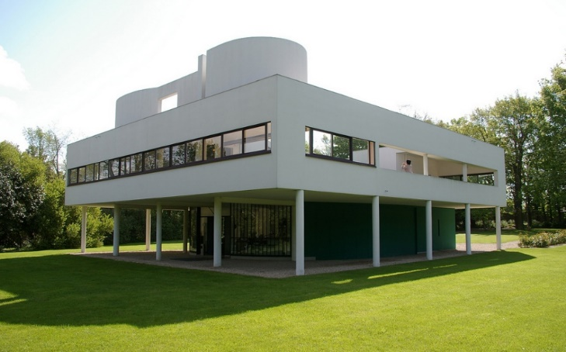

**Fig 2.** Villa Savoye, embodiment of Corbusian Five Points for a New Architecture. (Curtis, 1986)

Free Plan project for Le Corbusier was not merely free arrangement of walls as spatial partitions separated from load-bearing columns; he suggested complex movement systems which are more than circulation systems. That is, traversing pathway, providing altering lookout points which play a key role in the experience of space. He referred to this concept as ‘Architectural Promenade’, namely, the observer's pathway through the built space. That is, sequence of images that unfolds before the eyes of the observer as he or she gradually advances through the structure.

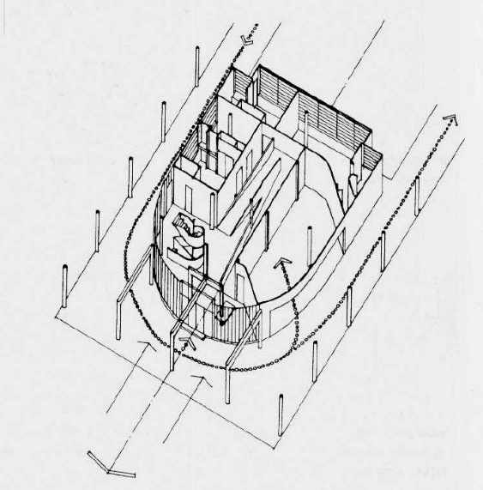

**Fig 3.** Villa Savoye, facilitated circulation in ground floor plan. (Baker, 1986, p.200)

Through ascending the levels of the building via the ramp one perceives the continuity of space while experiencing determined spatial sequences. As Rowe (1994) argued, In the Villa Savoye Corbusier incorporated the structural ideas from the Maison Domino with a ramp allowing for viewing Le Corbusier’s architectural promenade as it flows upward travelling inside and outside from the ground floor to the solarium. From the Rowe’s perspective, structural details of the Villa Savoye and Maison Domino can be noticed as "modern symbols of emancipation carrying implications of social liberty". (Rowe, 1994, p. 57(

Another prominent figure who has an essential contribution in developing Free Plan project was Mies van de Rohe; whose works extensively is reminded with the term "Universal Space". Mies never used the term himself, but typically referred to it as an ‘Open Plan’ or ‘Free plan’ and in some cases ‘clear, uncluttered spaces’. In general, "universal space discuss the issue of undivided expanse in terms of functional purpose, enabling the flexible use of inner space." (Kim, 2006) Moreover, it addresses association and the continuity between inside and outside spaces

.

Free Plan project, or as he usually referred Open plan, for Mies was a lifelong search for spatial continuum and spatial dynamism. In his magnificent triumph, namely German Pavilion in Barcelona (1928-29), he articulated space freely, opened it up and connected it to the landscape. According to Mies: "dynamic space articulated by freestanding walls and continuous space opening towards the outside, were present due to external glass skins." (Kim, 2006)

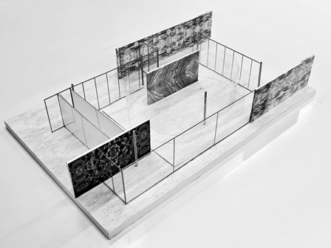

**Fig 4.** Brcelona Pavilion model, fluidity of space in Miesian open plan. (n.d.). Retrieved January 18, 2019 from http://www.archdaily.com/109135/ad-classics-barcelona-pavilion-mies-van-der-rohe

Although Le Corbusier and Mies van de Rohe both involved in Free Plan project around the same time, but nevertheless each of them had their personal originality in developing the project. Whereas in Villa Savoye Corbusier utilized the ramp to conduct the visitors, in Barcelona Pavilion, Mies employed freestanding walls to direct the audiences' movement. If Mies sought more continuity in space through light extroverted construction which eliminated boundaries between inside and outside, Corbusier looked for spatial liberation within pure geometrical forms. "While Mies saw geometry as a structural construct disclosing an empty space, Le Corbusier saw geometry as the language of an architecture whose plastic appearance should impress the senses." (Kim, 2006) That is to say, while Corbusier directed to theorize a new formal characteristic as Purism, Mies aspired for subverting objective aspects of architecture.

* 1. **Free Section Project**

The profound impression of the celebrated modern icons, specifically Le Corbusier and Mies van de Rohe on forming Rem Koolhaas’s notion cannot be underestimated. Through identifying major influence of Le Corbusier on Koolhaas, among striking formal similarity between some of their design, Jeffery Kipnis asserted: "there is no other way to put it; [Rem] Koolhaas is the Le Corbusier of our times." (Kipnis, 1996) Koolhaas in Content, like his typical polemical attitude stated: "I do not respect Mies, I love Mies. I have studied Mies, excavated Mies, reassembled Mies. I have even cleaned Mies. Because I do not revere Mies I’m at odds with his admirers". (Koolhaas et al., 2004(

At the beginning of the 1990s, more than a decade since he had established OMA, Koolhaas developed a new project to cast about more spatial liberation, yet he sought this kind of freedom in vertical section. Unlike Le Corbusier who looked for spatial emancipation in horizontal section namely plan, or dissimilar to Mies van de Rohe’s aspiration for continuity and fluidity of space within the structural grid; Koolhaas searched for strategies to undermine the dominating effect of the parallel floor slabs that conspicuously bound the space. The mentioned project became prominent as the so called ‘Free Section’.

Via analyzing the section of villa Savoye, the essential factor which attracted koolhaas was not any of the Corbusian five points; rather he noticed the crucial role of the ramp that extends between the floors from the lower level to the rooftop solarium, in providing continuity of vertical movement throughout the building. Although Le Corbusier subtly issued the idea of the ramp and sequential perception via architectural promenade, but nevertheless he did not mention that among his five points.

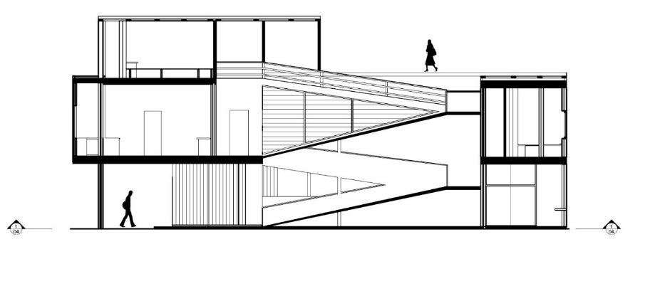

**Fig 5.** Villa Savoye, cross section. (Curtis, 1986)

Koolhaas deftly perceived the key role of the ramp in the section of the villa Savoye, and therefore utilized it as the essential element in circulatory system of Kunsthal in Rotterdam (1987–92). Kunsthal was located in the intersection of two routes: one extended east/west parallel to the main road and the other was running north/south. These crossing tracks would divided the square in four separate parts; accordingly, the main challenge was to find a concept that interrelated these sectors. The concept of the building was a continuous circuit comprised two ramps which running parallel but reversed. (Koolhaas and Mau, 1995)

Koolhaas skillfully adapted the notion of Le Corbusier's architectural promenade in circulation area, so that providing a fluid space in the whole structure. That is, from the main entrance which was at the intersection of two ramps, the observers experienced unique series of viewing moments as they gradually rise or decline through the ramps. In fact in Kunsthal koolhaas not only strived to accomplish fluidity and dynamism in space, but also as he asserted in Content, implemented "system of intersecting ramps that destroy the status of the individual floor." (Koolhaas et al., 2004)

In his analysis about Kunsthal, Moneo asserted, "Koolhaas's strategy of activating the neutral volume that defines the perimeter is carried out on two fronts. …The prism is transformed by means of a series of slanted planes that help consolidate the program while fostering movements". Furthermore, Moneo mentioned directly about the influence of the Corbusier on Koolhaas in occupying ramp as he stated,"the rectangle band is broken into a series of transverse bands associated with functions, uses and services. Koolhaas skillfully introduces a ramp, which is associated and allows us to speak once again of Le Corbusier's influence on his work." (Moneo, 2004, p. 354)

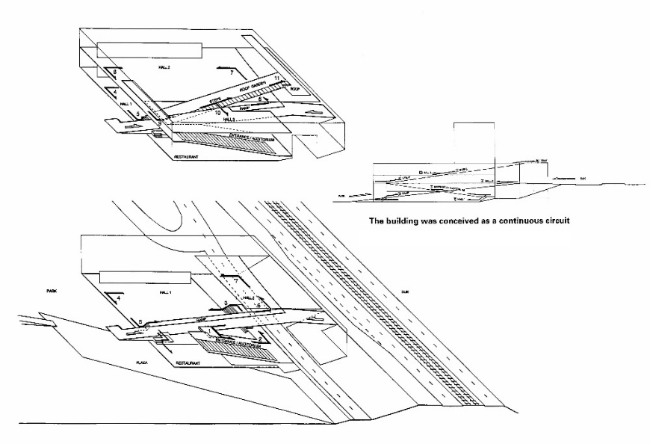

**Fig 6.** Kunsthal, diagram of two ramps. (OMA, El Croquis 53+79, 1998)

Kipnis also argued about the influence of the Corbusian notion of Free Plan and Miesian notion of Open Plan on Koolhass in developing the idea of Free Section. As he mentioned, "no practice has made more cunning use of the differences between Corb’s free-plan and Mies’s stage-plan than OMA, which has synthesized the two into an architecture that, in its critique of the two, posits a fundamental shift in the liberal project from the Modernist … The free-section, then, is the necessary invention; a recasting of the metropolis’s vertical infrastructure into a building device to achieve the unregulated anonymities that are not possible in free-plan". (Kipnis, 2005)

The Free Section project for Koolhaas was not merely bound to the issue of the circulation, namely, providing seamless movement of the subject via circuit of the ramps skillfully link the floor slabs together, yet he also sought for spatial emancipation via increasing voids as much as possible over solids in section. In his proposed design for Bibliotheque de France he totally reverse the traditional understanding of section concerning the balance between solids and voids. As he elaborate his proposal, "the Very Big Library is interpreted as a solid block of information, a repository of all forms of memory – books, laser disks, microfiche, computers and databases. In this block, the major public spaces are defined as absences of building, voids carved out of the information solid. Floating in memory, they are multiple embryos, each with its own technological placenta." (OMA, 1989)

Accordingly, in Bibliotheque de France, space was defined by voids and the solids were just residue of the implied space. As Moneo argued, "in the floor plans and sections, however, the space fills up and is constructed by means of voids in which those functions are produced." (Moneo, 2004, p. 341)

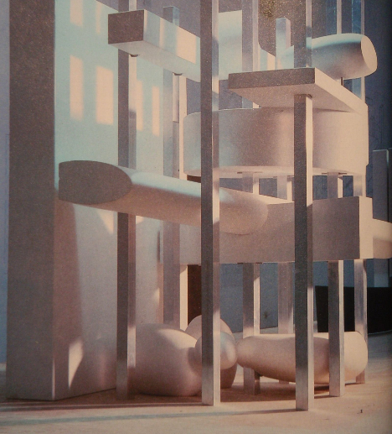

**Fig 7.** Bibliotheque de France, Model for Competition demonstrates the priority of the voids over solids. (OMA, El Croquis 53+79, 1998)

The most groundbreaking exemplar of Free Section project was OMA’s proposal in the competition for the two Jussieu university campus libraries in Paris (1993). The significant point of koolhaas'*s* proposal was the advancement of Free Section project to ‘continuous surface strategy’. Their extraordinary scheme utilized "continuous surface as pliable, a social magic carpet", thus "forming a single trajectory much like an interior boulevard that winds its way through the entire building." (Koolhaas and Mau, 1995) The floors were manipulated to connect each other, generating "a vertical intensified landscape." (Koolhaas and Mau, 1995) The consequence was a single continuous trajectory through which visitors experienced dynamic fluid space, liberated from stacked floor slabs.

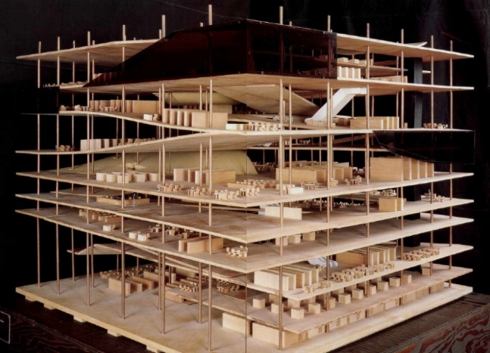

**Fig 8.** Jussieu Library, Model for Competition shows a single continuous trajectory joining the floor slabs throughout the building. (OMA, El Croquis 53+79, 1998)

Later, Koolhaas developed the idea of continuous surfaces in several works. The main aim was challenging traditional definition of every formal surfaces namely roofs, walls and floors. Since each of them has the potential to bound the space, Koolhaas chase the continuity and fluidity in space by joining them together as a single continuous surface. For instance in Educaturium in Utrecht two planes folded, wrapped and interlocked to each other to encapsulate a range of distinct programs. Notwithstanding the space is sandwiched between two planes, converting concrete floor plates to wall and then to ceiling yield a sense of fluidity.

This idea was developed by two young proteges of koolhaas who have worked in OMA, Farshid Moussavi and Alejandro Zaera-Polo. After founding their own office (FOA), in a competition for Azadi Cineplex in Tehran, they proposed a unique scheme which was totally besed on the strategy of folded continuous surfaces.

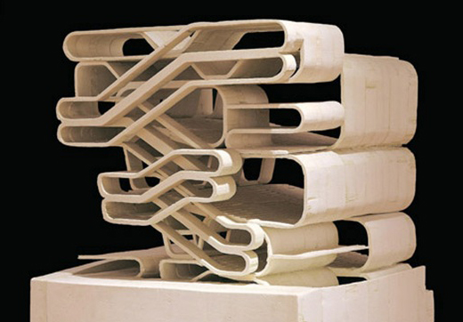

**Fig 9.** Azadi Cineplex, Model for Competition demonstrated floor slabs a folded continuous surfaces. (FOA, El Croquis 115+116[I], 2003)

The concept of the design was a filmstrip, rising from the ground in several folds, comprising all the programmatic requirements such as auditoriums, necessary access and supplementary commercial and cultural spaces. In order to eliminating the structural grid system, the formal structure was also to become the load-bearing structure. That is, unlike its predecessors Jussieu library and Educaturium, here the folded continuous surfaces not only act as structural system but also they shape the circulatory system of the complex. Therefore, the observers experience continuous fluid space when they go through different parts of the cineplex.

Although Azadi cineplex was a great achievement in terms of liberating the space from traditional restrictions, but nevertheless the traces of Euclidian geometry could be traced as implied framework over the folded surfaces.

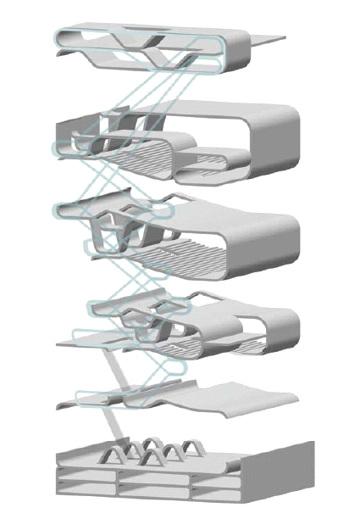

**Fig 10.** Azadi Cineplex, Diagram of Folded Surfaces. (FOA, El Croquis 115+116[I], 2003)

* 1. **Boundless Space Project**

The dialectic between form and space always has been a matter of paradox in architectural theory. That is, nevertheless form with all its features is the essential implement for architects to define space, yet it bears boundaries which interrupt spatial emancipation. Thus, to accomplish boundless space, architecture should cast about for strategies which challenge all the traditional definition of its elements as well as hierarchical orders dominating the realm

.

Whereas the former two projects, meaning Free Plan and Free Section, by accepting whole nature of the form as an independent phenomenon, merely look for spatial liberation through challenging sub formal elements; in Boundless Space project not only the utter character of the form including its established prototypes is being questioned, but also the institutional hierarchical orders is being queried.

Since this project has opened up a broad horizon to architectural design, different strategies have been developed during last two decades aiming for the liberation of space from imposed boundaries. Owing to logical coherence, this paper only focused on the work of FOA and follow their shift from Free Section project to Boundless Space project in their works.

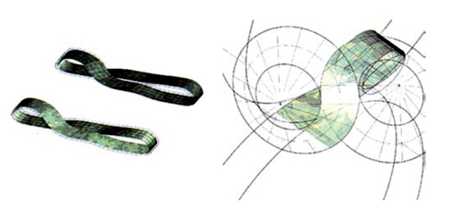

**Fig 11.** Virtual House, Mobius Diagram. (FOA, El Croquis 115+116[I], 2003)

In their design for the Virtual House FOA integrated the Mobius strip pattern with continuous surface strategy in order to challenging conventional separation between different sectors of domestic space. Employing the Mobius strip brought about topological surface in which every face of the surface shifting constantly between a lining and a wrapping condition. Consequently, the boundaries between inside and outside, Bottom and top were dissolved. While a diagonal shift in the plan increased the spatial complexity, differentiation between separate parts was blurred in favor of continuous fluid dynamic space.

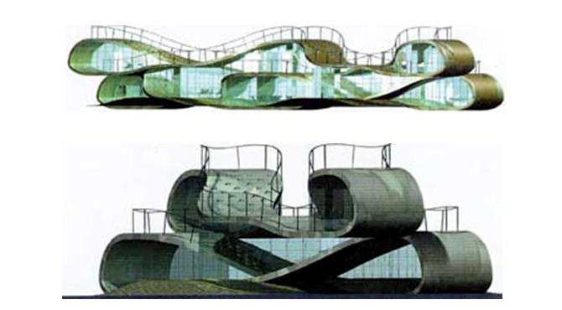

**Fig 12.** Virtual House (FOA, El Croquis 115+116[I], 2003)

Culmination of this strategy, namely utilizing topological structure being integrated with folded continuous surfaces, indubitably can be discerned in their iconic project Yokohama International Port Terminal.

The starting point of the design was the concept of Ni-wa-minato: a differential mediation which was proposed by the client. It indicated mediation between garden and harbor, but also between the citizens of Yokohama and those from the outside world. That is to say, the brief of the Yokohama International Port Terminal asked for the articulation of a passenger cruise terminal and a mix of civic facilities for the use of citizens in one building.

Accordingly, the terminal will operate as a mediating device between the two large social machines that make up the new institution: the system of public spaces of Yokohama and the management of cruise passenger flow. As FOA argued, their proposal for the project started by declaring the site as an open public pace and proposed to have the roof of the building as an open plaza, continuous with the surface of adjacent public parks.

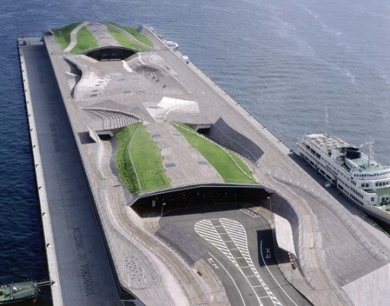

**Fig 13.** Yokohama Ferry Terminal (FOA, El Croquis 115+116[I], 2003)

Since the flow of passengers and circulation system play a key role in terminal, according to FOA: "the generator of the design was a circulation diagram that aims to challenge the linear structure characteristic of piers,...Starting with the idea of the ‘no-return pier’ we aimed to structure the building as a fluid, uninterrupted and multi-directional space." (FOA, 2005)

Via occupying a series of interlocking circulation loops, they undermined the traditional characteristic of the conventional terminal as a gateway to flows of passengers in predetermined orientation. Moreover, FOA attempted to subvert reciprocal territorialization between the city and waterfront. “Rather than conceiving the building as an object on the pier, the project is produced as an extension of its ground, constructed as a systematic transformation of the lines of the circulation diagram into a folded and bifurcated surface.” (FOA, 2006)

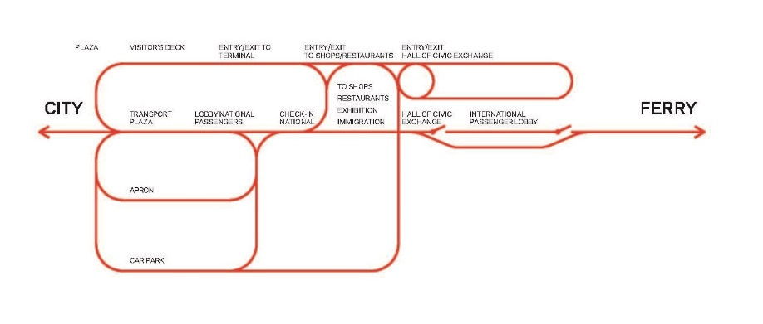

**Fig 14.** Yokohama Ferry Terminal, No Return Circulation Diagram. (FOA, El Croquis 115+116[I], 2003)

These folded surfaces yield covered area where the various segments of the program hosted throughout a continuously varied form; besides, ground surface acted as an urban public space. The ground of the city seamlessly connected to the boarding level, thus the terminal will become an extension of the city; meaning the passengers will experience a fluid uninterrupted dynamic boundless space.

1. **Conclusion**

Architecture discipline enjoyed unprecedented accelerated ¬advancement of technology in twentieth century; therefore, three major projects have been developed on the same approach, namely, an architectural meta-project seeking for spatial emancipation and overcoming traditional boundaries of space.

Each of these projects, with deep perception of the zeitgeist, was critical response to the traditional imposed restrictions on the discipline of architecture. As it has been illustrated in this paper, regarding to this certain approach, a precise interdependence between these three major projects could be traced in their process of evolution. That is, each project developed its strategies based on the established strategies which inherited from its precursors. For instance, Free Section project is profoundly based on the achievements of Free Plan project; furthermore, through analyzing FOA' works, one can trace the subtle development of continuous surface strategy from Free Section project to Boundless Space project. In fact Through Each project, aiming to push the boundaries of discipline, pioneering strategies has been developed which later became the foundation for evolution of new Project.

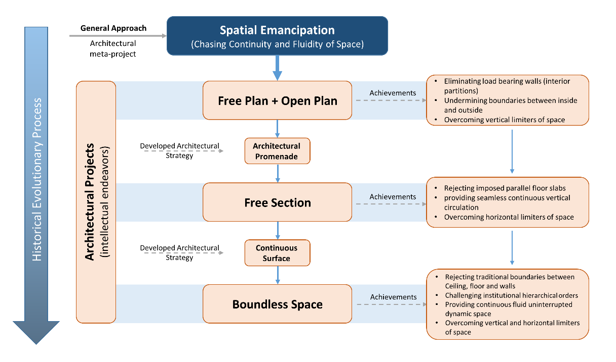

**Fig 15.** Diagram shows interrelations of architectural projects seeking for spatial emancipation in a historical evolutionary process. (Developed by authors)

Although architecture discipline should benefit the opportunities which is granted from other disciplines, but nevertheless it has a crucial need to define its own projects. Since achieving specific spatial characteristic is owing to develop a certain strategies inside the discipline of architecture. The world of architecture today needs critical and transformational projects in order to open up new windows to the discipline. Accordingly, undertaking such studies which attempt to comprehend the interdependence and evolution of canonical strategies will contribute to develop pioneering strategies to achieve more spatial liberation.

**Acknowledgement**

The authors would like to express their gratitude to Tarbiat Modares Unviersity, department of architecture’s academic staff for providing instructive atmosphere and also appreciate their kindly support.

**References**

Allen, S. (1999). PRACTICE vs PROJECT. *PRAXIS: Journal of Writing + Building, 1, 0*, 112-115.

Baker, G. H. (1996). *Le Corbusier: an analysis of form* (3rd Edition). New York: Van Nostrand Reinhold.

Benton, T. (2007). *The villas of Le Corbusier and Pierre Jeanneret: 1920-1930*. Basel: Birkhauser.

Curtis, W.J.R. (1986). *Le Corbusier: Ideas and Forms.* London: Phaidon Press.

Curtis, W.J.R. (1996). *Modern Architecture since 1900.* New York: Prentice-Hall.

Foreign Office Architects. (2005). *Phylogenesis: FOA's Ark.* Barcelona: Actar.

FOA, Foreign Office Architects. (2003). [Special Isuue]. *El Croquis 115+116[I]* (1996–2003).

Hays, K. M. (1998). *Architecture theory since 1968*. Cambridge, Mass: The MIT Press.

Kim, R. (2006). *The “Art of Building” (BAUKUNST) of Mies van der Rohe.* Ph.D. Dissertation, Georgia Institute of Technology.

Kipnis, J. (1996). Recent Koolhaas. *El Croquis, 79*, 26-37.

Kipnis, J. (2005). On Criticism, Moneo’s Anxiety. *Harvard Design Magazine, 23*, 96-104.

Koolhaas, R.; AMOMA et al. (2004). *Content: Triumph of Realization.*  Köln: Taschen Press.

Koolhaas, R. and Mau, B. (1995). *S,M,L,XL.* New York: Monacelli Press.

Le Corbusier (1923). *Towards a New Architecture.* Translated by Goodman, J. (1985). New York: Dover Publication.

Manack, M. (2016). Practice as Autonomous Object. *The Plan Journal*. Retrieved from http://www.theplanjournal.com/system/files/articles/TPJ0_0_5_Art_Prof_Marc_Manach.pdf

Mirmiran, H. (1996). *A New Movement in the Architectural Tradition of Iran*. Architectural Association (AA), London, 24 January 1996.

Moneo José Rafael. (2004). *Theoretical anxiety and design strategies in the work of eight contemporary architects*. Cambridge, MA: MIT Press.

OMA, Rem Koolhaas (1987–1998). [Special Isuue]. *El Croquis 53+79* (1998).

OMA. (1989). *Très Grande Bibliothèque*. Retrieved from https://oma.eu/projects/tres-grande-bibliotheque

Rowe, C. (1994). *The Architecture of Good Intentions: Towards a Possible Retrospect*. London: Academy Editions.

Syracuse Architecture. [Peter Eisenman: "Project or Practice?"]. (2013, April 15). [Video file]. Retrieved from https://www.youtube.com/watch?v=TnyJRYyuhHU