|  |
| --- |
| **Investigating Potential Design Strategies to Provide Field Condition in Architecture**  Babak Ashtari 1, Mansour Yeganeh 2   1. PhD Candidate, Department of Architecture, Tarbiat Modares University, Tehran, Iran 2. Assistant Professor, Department of Architecture, Tarbiat Modares University, Tehran, Iran |
|  |
|  |
| *Corresponding Author: Babak1980.architect@gmail.com |

**Abstract**

*Scientific approach to architectural design, namely, multidisciplinary approach to design aiming to incorporate innovative theories from other majors to develop novel architectural concepts has been prevailing in recent decades. However, when certain theory proposes particular spatial characteristic, the significant point is distinguishing precise strategies which are potential to progress the design process to achieve aspired spatial condition. In the early decades of 20th century when new conception of "field" emerged, the whole former premises about the space has altered to a new conception of space-time as a single four dimensional continuum. In effect, "Field Theory" brought forward new conception of empty space as "field condition" which has profoundly influenced art and architecture, specifically in the second half of the last century. Nevertheless, not only there are considerable shortcomings regarding elaboration of principal notion of field condition in architecture, but also certain design strategies which are capable to generate projects in line with specific spatial characteristic of field condition has not been distinctly investigated. Thus, this qualitative documentary research based on literature survey will concern itself, first with reviewing the field theory and its essential proposed idea of empty space, then second, inquiring potential design strategies to provide field condition in architecture. Accordingly, through reviewing the concept of field in physics and regarding canonical texts in architecture literature, the essential notions of field condition will be determined. Subsequently, Three cases which their spatial characteristic are in line with determined notion of field condition will be analyzed to find out precise design strategies by which this particular spatial feature has been developed. The findings demonstrated Twice and Algorithmic Repetitive Pattern are potential to provide field condition in architecture, yet when they are incorporated with each other in a proper manner then consequent spatial characteristic will be precisely in line with the field condition.*

**Keywords:**

*Design strategy, Field theory, Field condition, Void, Space*

1. **Introduction**

In the course of the recent decades, conspicuous alteration has occurred concerning design perspectives in architecture. That is a shift from consideration of the outcomes of design towards careful attention to process of design. In other words, the determined process wherein primary crude ideas, through occupying appropriate patterns are converted to basic concepts, becomes more accentuated vis-à-vis properties of the result. Accordingly, finding this patterns, namely certain design strategies which is capable to progress intermediary stages of the design process turned into main concern for architects. In Effect, "today, the figure of the architect can no longer be seen only in terms of producer of objects, but rather as a strategist of process". (Cros and Gausa, 2003, p. 573)

Consequently, design strategies deal with the rules that govern the process of design from basic subjective ideas to primary objective formal concepts. That is the very ground for widespread employment of inventive theories from other disciplines, namely an interdisciplinary approach to architectural design. While the innovative theories from other disciplines trigger new idea of space, yet certain design strategies concerning discipline of architecture are required to achieve that specific spatial characteristic.

Field theory can be considered as one the most significant breakthroughs in physics which began in the late 19th century with Faraday and Maxwell, and reached to its peak when Einstein published his *general theory of relativity*. An ingenious revolutionary explanation of space-time as a four dimensional contingent phenomenon which utterly changed the idea of space. In fact, Einstein unified the idea of space with the idea of time into four dimensional structure called space-time. Through the discovery of this unexpected link between space and time Einstein realized that the two could no longer be thought of as separate things, instead space and time are fused together and came to be called Space-Time. (see Greene, 2004, pp.39-77) Consequently, the empty space which traditionally considered as passive stage against which action of the universe has been occurred, turned into mysterious phenomenon, namely the field, potential to influence all the stuffs.

This new conception of space has significant influence on the art and architecture, particularly in the late decades of twentieth century. Although there are noticeable treatises regarding inspiration of this new concept of field on avant-garde artists, but nevertheless when it comes to architecture the shortage of canonical texts, addressing influence of this new conception of field on architectural theory is conspicuous. Moreover, the precise strategies which are capable to generate projects with particular characteristic of field condition has not been investigated.

* 1. **Objectives and Method of Study**

The aim of this qualitative documentary research based on literature survey is first, elaborating new concept of the field with focus on its essential proposed idea of space in order to determine the characteristic of field condition in architecture, and second, probing design strategies which are potential to provide field condition as a certain spatial characteristic in architecture. In doing so, through descriptive-analytic method the field theory in physics with the focus on Einsteinian Field and its consequential alteration in notion of space will be elaborated and canonical texts which addressed the notion of filed in architecture literature will be reviewed to determine the essential notion of field condition. Thereafter, three cases which their spatial characteristics are in harmony with determined notion of field condition will be studied to discover which strategies in their design process were occupied. As a consequence of this procedure, it will be shown that there are certain strategies which are capable to generate projects with determined characteristics of filed condition in architecture.

1. **The Notion of Field**

In physics, field can be considered as a region in which each point is affected by a force. That is, the area or space under the influence of, or within the range of, some agent. (The Columbia Electronic Encyclopedia, 6th ed.) In a simple interpretation, every object in the field has the influence on other objects and it is influenced by them. That means, the objects are not autonomous, rather they are in relation to each other in a manner that they constitute a whole inseparable from its ingredients.

The modern idea of the field in physics began around the late nineteenth century in the work of Faraday and Maxwell, who eventually were able to explain the real physical nature of electrical and magnetic phenomena in terms of a single entity, the Electromagnetic field. Yet, this notion stemmed from an older idea prevailing from ancient Greek to the early twentieth century. That is, a common agreement about a medium in space apart from matter which they named it as ether.

In the philosophy of Aristotle there were four major elements of the world: fire, wind, earth and the water. Yet, in order to explain some uncommon problems, he suggested the fifth element, namely, quintessence which exists only in the celestial regions of the universe. Even for Newton in view of his remarkable achievements,to wit theory of Universal Gravitation and particle theory of light, the ether was an invisible medium quite distinct from both light and matter. After enduring challenge Newton was convinced to explain transmission of gravitational forces by means of ether as a proper medium, but the idea of ether for Newton had little in common with the classical notion which it has been derived. (McMullin, 2002) Although Maxwell demonstrated that electric and magnetic field travels through space as waves but he was compelled to posit a material vehicle or medium for this electromagnetic field: the luminiferous ether. (Kwinter, 1986) That is, light-bearing ether as presupposed medium for the propagation of light.

In parallel with the evolution of the notion of ether, the idea of space has been developed from ancient times. The principal concept of space was founded on Euclidean mathematics for which space, as a continuum with its own independent reality, was never fully posited. The elements of this system, namely the point, the line and the plane were nothing more than idealizations of solid bodies. Space itself emerged only secondarily, that is, only insofar as it could be derived from these idealized forms and the relations produced by their contact. (Kwinter, 1986)

It was the first time with Descartes that space perceived as autonomous and pre-existing, an infinite and generalized three-dimensional continuum, where points and figures are describable by their coordinates. (Kwinter, 1986) That is to say, space now existed independently of solid bodies, preceding them and containing them. All the equations of motion and acceleration in Newtonian physics is deeply indebted to Cartesian coordinate system. Events and motions in this system comprehended in the uninfluenced conveyor as an unchanged background.

This conception of space and time faced two critical issues in the late nineteenth century: heat (internal energy) conduction in solid bodies relating to thermodynamics, and electromagnetic interaction and the wave-theory of light relating to electrodynamics. As a result of these problems two theories have been developed; field theory of masses in thermodynamics and field theory of empty space in electrodynamics.

* 1. **Einsteinian Field and new Conception of Space**

In his seminal 1905 article, On the Electrodynamics of Moving Bodies, Albert Einstein proposed his Special Theory of Relativity for the first time. Its radicalness laid in liberating time from its metaphysical and absolute character and reducing it to just one more dependent coordinate in the kinematical transformation equations. Subsequently in 1915, Einstein published his groundbreaking General Theory of Relativity, in which he unfolded a new understanding of gravity as a shape of space-time. In this new single fabric of space-time as four dimensional continuum, "time and space were no longer, at least algebraically, heterogeneous; the continuous 4-dimensional manifold could no longer be separated into a three-dimensional section evolving in one-dimensional time." (Kwinter, 1986) The Einsteinian field totally invalid the necessity to postulate a material substratum as a conveyor for forces.

Through this new conception of space and time as a dependent and contingent phenomenon, namely space-time which is irreducible to their component dimensions, the notion of space was totally changed. It was the first time that human science were capable to explain one of the deepest mystery in physics, that is, the answer to this fundamental question: if all the stuffs in cosmos were eliminated what would be left? In fact, for the first time in its enduring evolution, human knowledge were able to make sense of something that looks nothing, that is, empty space. This new conception of space-time as a single 4-dimensional manifold, was not in accord with Newtonian proposed idea of absolute time and absolute space, and more accurately it rejected Newton's notions. With Einstein the empty space is not nothing, it is something with real characteristics, namely flexible kind of geometry. It has the potential to influence objects and arrange them. That is, the field. (Greene, 2011)

Accordingly, the whole universe can be understood as interaction between fields. From extra-large scale galaxies, to tiniest things like atoms, as the basic ingredients of all materials, are almost entirely empty space. Principally, Einsteinian field indicated the manner that the whole universe is governed. Fundamental interactions, also known as fundamental forces, are the interactions in physical systems that do not appear to be reducible to more basic interactions. There are four conventionally accepted fundamental interactions: gravitational, electromagnetic, strong nuclear, and weak nuclear. Each one is understood as the dynamics of a field. (Davis, 1986)

This conception is distanced far from the Newton's idea of space. For Newton, space was empty stage, a framework for everything that happens in the cosmos, an arena wherein the drama of the universe plays out. According to Greene, "To Isaac Newton, space and time simply formed an inert, universal cosmic stage on which the events of the universe played themselves out." (Greene, 2005, p.6) That is, a passive stage, absolute, eternal and unchanging, the action could not affect the stage and stage could not affect the action. Yet, after Einstein space can no longer be thought as static stage, it is an active actor who plays a leading role. In fact, Einstein demonstrated that "Newton's Ideas of absolute space and absolute time were wrong". (Greene, 2005, p.47)

* 1. **Field Condition in Architecture**

Although some footprints of field theory can be traced through influential architectural projects in recent decades, but nevertheless there are only a few canonical texts in existing literature regarding the subject. Probably the first treatises in which one could find some concealed indications to field theory are Eisenman's two consecutive essays in the early 1970s, under the title of From Object to Relationship. Through incorporating linguistic analogy, particularly Chomsky's notion of deep structure, Eisenman argued about syntactic relationship between formal elements. He subtly differentiated between two distinct kinds of relationship as he proclaimed: "In architecture both types of relationships exist simultaneously. There is a surface aspect essentially concerned with the sensual qualities of the object; ...There is also a deep aspect concerned with conceptual relationships which are not sensually perceived". (Eisenman, 1971)

Indubitably the first canonical disquisition in architecture literature which clearly addressed the notion of field was kwinter's seminal extensive essay of 1986, La Citta Nuova: Modernity and Continuity, wherein he illustrated the significant change regarding conception of space in wake of Einsteinian notion of field. Although the main issue of the article was not about the field, yet in order to furnish the prerequisite knowledge for discussing about the plastic dynamism in work of futurist architects, he elaborated the modernity's milieu in early twentieth century and its momentous scientific achievements. Accordingly, he argued about the Einstein's theories of relativity and their crucial role in shaping new conception of space-time, that is, the notion of field. He gave a clear definition of field and subtly pointed how this new concept, namely the field, is the precise notion which has been conceived as the space hitherto where he argued, "The field describes a space of propagation, of effects. It contains no matter or material points, rather functions, vectors and speeds. It describes local relations of difference within fields of celerity, transmission or careering points, in a word, what Minkowski called the world." (Kwinter, 1986) Although kwinter's essay provided didactic information about the field theory and its development in physics, it did not address the consequence of theory in architecture.

Yet it was Allen's essay of 1997, Field Conditions: From Object to Field, which for the first time conspicuously addressed the notion of field in art, architecture and urbanism. As the title implied: "Field conditions move from the one toward the many, from individuals to collectives, from objects to fields." (Allen, 1997) Unlike Kwinter who delved in to origins of the theory in physics, Allen attempted to portray the characteristics of the field, albeit not in coherent manner, through various examples from pioneering art styles of the 1960s and 1970s and some instances from architecture and urbanism. Allen strived to not only illustrate influence of notion of field in pioneering art styles of the last century, but also set forth some noticeable points as principal characteristics of the field condition in architecture.

Through reviewing Allen's essay, certain contemplating points as main spatial features of field condition in architecture can be concluded. He argued while traditional conception of space were established on fixed and frozen geometrical patterns, or static representative images, the new conception of space gives way to comprehend the complexity of fluid, drifting and self-organizing spatial systems. He maintained: "to generalize, a field condition would be any formal or spatial matrix capable of unifying diverse elements while respecting the identity of each. …Overall shape and extent are highly fluid and less important than the internal relationships of parts, which determine the behaviour of the field. … Field conditions are relational, and not figural." (Allen, 1997) Allen subtly considered field as Perceptual but often invisible tension generated by system of physical spatial relationships as he stated: "Field conditions have a special capacity to make abstract forces visible." (Allen, 1997) He argued about the scale as important factor in field condition, since it is contingent upon repetition, and need a certain expanse to register.

What can be deduced from field theory in physics and principal points which were proposed by these canonical texts in architecture literature as the essential characteristics of field condition in architecture is first, significant role of the voids as dynamic space of interrelation between solids, and second, subversion of monolithic form on the side of relationship between formal elements. Thus, if one of these features can be found in a certain project as its main spatial characteristic, it can be considered as the sample of field condition from the scope of this paper.

1. **Case Studies**

According to deduced spatial characteristics of field condition in architecture, in the following chapter three cases will be analyzed in order to: first, designating their spatial characteristic is corresponding to the field condition, and then second, elaborating precise strategies which were occupied in their design process. These three cases has been selected in a way that each of them corresponds to the main deduced features of field condition in different manner, and since they occupied different design strategies, their investigation will provide logical structure to probe certain design strategies which are capable to issue field condition in architecture.

* 1. **Nara Convention Hall by Bahram Shirdel**

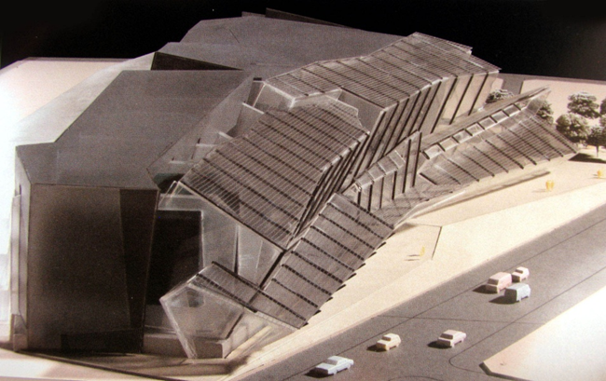

**Fig 1.** Nara Convention Hall (Shirdel, 1993)

For designing Nara Convention hall, Shirdel meticulously studied the spatial characteristic of the Todai-ji temple in Nara. He subtly found the temple space ruled by three figures: a giant central Buddha and two smaller lateral accompanying figures. This means to shirdel that peculiar spiritual atmosphere of the temple is related to the empty space sandwiched between the outer skin and the internal figures of the temple.



**Fig 2.** Todai-ji Temple, Daibutsa-den (Shirdel, 1993)

Profoundly inspired by this feature, Shirdel "adapted the transverse section of the temple and floated the three great masses of the theatres within a single envelope." (Shirdel, 1993) Thus, the visitor is compressed between the folded skin of the envelope and the folded masses of the theatres. Accordingly, the major part of the project is the residual space, yet not as merely static remnant between solids, rather it is dynamic influential space which indicates abstract forces of the masses. Even, Shirdel considered the vector of these forces as he altered the frontal orchestration of the figures in Todai-ji temple into axial arrangement of the floating theatres in convention center. Kipnis considered this particular feature as he argued: "Visitors to the Todai-ji temple encounter the Buddha figures frontally, a classical arrangement that emphasizes the subject/object relationship between the two. Shirdel, on the other hand, arranged his three sectional objects axially." (Kipnis, 2013) Consequently, when the spectators entered to the hall, they affected by field of forces resulted from interaction between outer envelope and three folded masses hovering on the side; therefore, they experienced historical-spiritual memory of the space of Todai-ji temple.

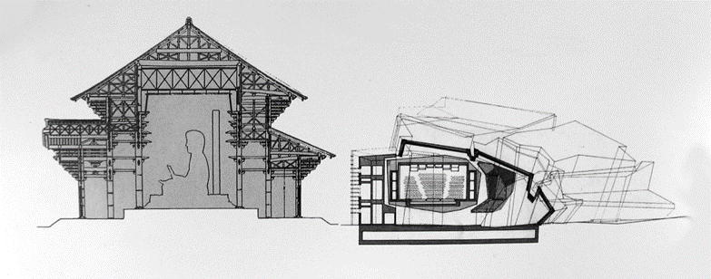

**Fig 3.** Transverse sections of Todai-ji temple (left) and Nara Convention Hall (Right) (Shirdel, 1993)

In view of the momentous of the void in this project, the substantial question is: through occupying which specific strategy Shirdel provided this field condition in Nara convention center? The answer lies in particular method in architectural design, that is, Twice. The essential idea behind this strategy is that when two different frequently dissimilar systems are set against each other, reciprocal interrelation between them provide unparalleled condition beyond the potential of each systems. The consequence is related to both systems, but is not belonging to any of them, that is, in-between condition resulted from interaction of two systems. (see Cros and Gausa, 2003, pp. 583-585)

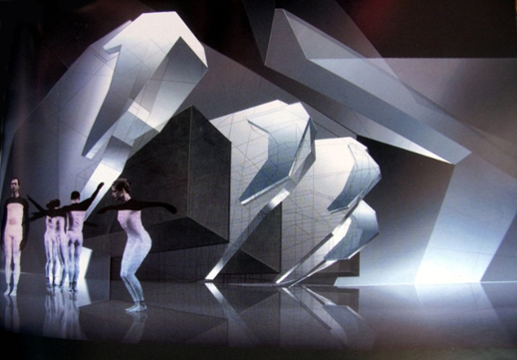

**Fig 4.** Nara Convention Hal, axially arrangement of three floating theatres (Shirdel, 1993)

In Nara project, Shirdel masterly employed this strategy, through establishing two distinct geometrical systems against each other. That is, occupation of two folds. kipnis elaborated this two fold systems which were employed by Shirdel and stated,"First, he reconfigured the massing of the original graft with a Thomian diagram of a hyperbolic umbilic fold, extending this fold into the surrounding landscape so as to smooth the connection of the building with its immediate site. Then he shaped the concrete piers holding up the three theaters and the lobby of the small music theater according to the parabolic umbilic fold." (Kipnis, 2013) Consequently, the main space of the hall is the dynamic field between the topology of these two folds.

* 1. **Serpentine Pavilion by Sou Fujimoto**

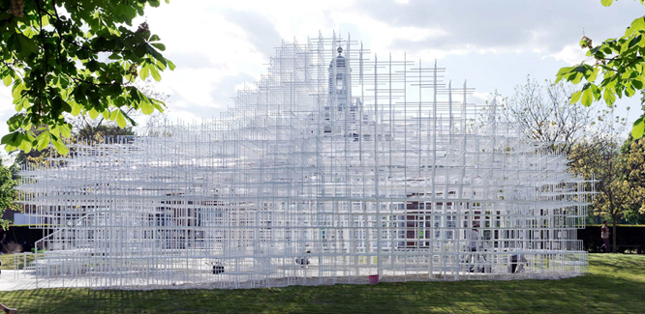

**Fig 5.** Portilla, D. (2013). Serpentine Pavilion by Sou Fujimoto. [image] Available at: http://www.archdaily.com/384289/serpentine-pavilion-sou-fujimoto [Accessed 11 May. 2016]

The 2013 serpentine pavilion in London, was a light semi-transparent, irregular cloud-like form which seems to gently merge into surrounding landscape. A Fragile lattice three-dimensional structure which provided different stepped terraces for visitors to find their favourite space encouraging them to create their own experience of the pavilion. Fujimoto (as cited in Quintal, 2013) explained his project as "a transparent terrain that encourages people to interact with and explore the site in diverse ways". In fact, through integrating the natural surrounding plant life with a man-made constructed geometry, Fujimoto created special environment wherein "the natural and the man-made merge; not solely architectural nor solely natural, but a unique meeting of the two."

In order to achieve this fluid structure, Fujimoto considered the pavilion as relationships between a number of identical elements within a flexible topography of the grid. He totally undermined the monolithic form on the side of dynamic steel grid which morphs on each side like the mist rising from the ground of the park. When visitors entered the pavilion they involved into influential interrelation of gridded structural elements, that is, a field condition wherein the subject is affected by abstract forces. This give rise to the critical question: Through employing which design strategy Fujimoto could produce such a delicate structure which is capable to provide field condition?

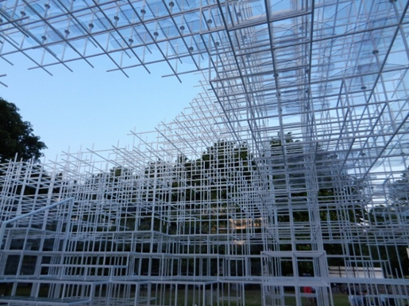

**Fig 6.** Portilla, D. (2013). Serpentine Pavilion, semi-transparent cloud-like structure. [image] Available at: http://www.archdaily.com/384289/serpentine-pavilion-sou-fujimoto [Accessed 11 May. 2016].

The innovative strategy where employed by the Fujimoto through design of serpentine pavilion was Algorithmic Repetitive Pattern. In this strategy a certain module as the basic pattern is subjected to a computational process of repetition. Whereas the basic pattern is constant, the predetermined algorithm dominated the process of repetition. Thus, it can provide different complex structures from similar basic pattern. The crucial point is that the output of this strategy is not monolithic geometrical figure, rather is fluid dynamic non-hierarchical structure. (Terzidis, 2006, pp. 65-103)

In serpentine pavilion the basic pattern of the complex structure is 40 centimeter rectangular steel post which is subjected to process of 20000 repetitions. (Portilla, 2013) From the Cartesian gridded result, it is apparent that the occupied algorithm ruled the process of repetition according to linear perpendicular distributional path. The fluid dynamic resulted structure distanced far from certain static geometrical figure.

The innovative strategy where employed by the Fujimoto through design of serpentine pavilion was Algorithmic Repetitive Pattern. In this strategy a certain module as the basic pattern is subjected to a computational process of repetition. Whereas the basic pattern is constant, the predetermined algorithm dominated the process of repetition. Thus, it can provide different complex structures from similar basic pattern. The crucial point is that the output of this strategy is not monolithic geometrical figure, rather is fluid dynamic non-hierarchical structure. (Terzidis, 2006, pp. 65-103)

In serpentine pavilion the basic pattern of the complex structure is 40 centimeter rectangular steel post which is subjected to process of 20000 repetitions. (Portilla, 2013) From the Cartesian gridded result, it is apparent that the occupied algorithm ruled the process of repetition according to linear perpendicular distributional path. The fluid dynamic resulted structure distanced far from certain static geometrical figure.

* 1. **Holocaust Memorial in Berlin by Peter Eisenman**

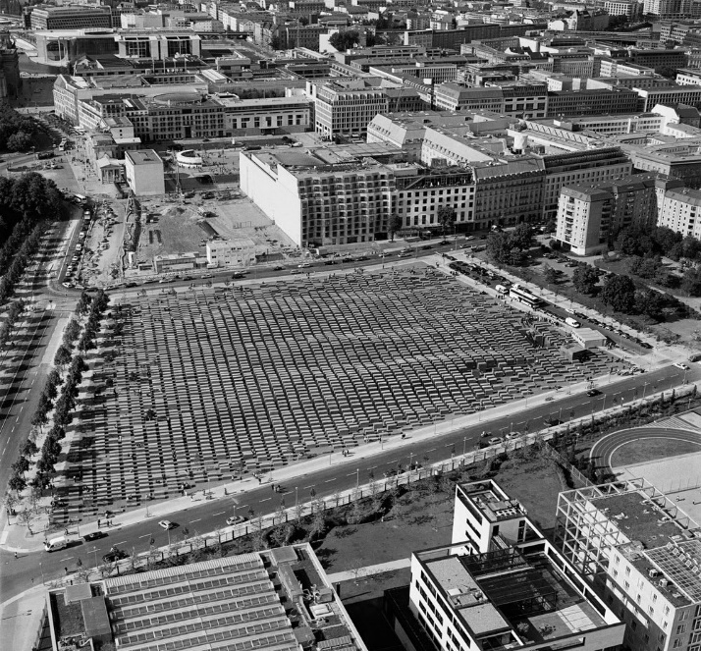

**Fig 7.** Binet, H. (n.d.). Berlin Holocaust Memorial. (Eisenman, 2005)

Memorial to the Murdered Jews of Europe, is an extraordinary undulating artificial landscape in Berlin, consisting 2711 concrete steles with identical surface area yet different height. Here the monolithic form is totally subverted towards fluid dynamic relationships between serial of non-hierarchical gridded objects. As Corbo argued, "The result of such an operation is a heterogeneous force field, characterized by spatial compression, increase or reduction of visibility, and different gradients of density." (Corbo, 2014, p. 96)

Eisenman, strived to resurrect memory of the trauma in the voids between solids. When visitors go through the various in-between spaces, namely come into contact with the voids, they are affected by exceptional mysterious field of forces which is capable of generating extraordinary experience. As he argued: "When you walk in the field of pillars you experience something very different from an ordinary urban space – it has nothing to do with the holocaust; it has nothing to do with the program, but the space is different, the sound is different, the materiality is different, and so the affective experience is." (Ansari and Eisenman, 2013) In the Berlin Holocaust Memorial, Eisenman attempted to deny opticality, that is, primary condition of this work is not what you see but what you feel. In other words, this project as Eisenman asserted, aimed to oppose the "the problem of metaphysics of presence, the fact that all presence is not only presence but the representation or the sign of presence". (Eisenman and Koolhaas, 2010, p.8) Whereas from outside, the project seems to be dominated by unitary pattern, but in its interior voids any stability gives ways to dynamism and fluidity.

This spatial characteristic is genuine representation of field condition in architecture, because here not only the monolithic form is subverted in favour of a number of formal elements, but also the dynamic voids between solids are clearly accentuated. Thus, the significant point is that through employing which design strategy Eisenman could achieve this certain spatial characteristic?

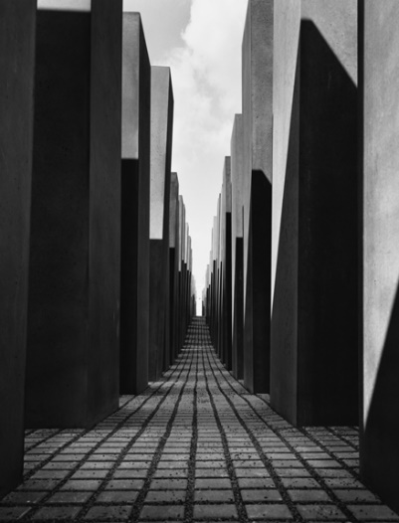

**Fig 8.** Binet, H. (n.d.). Berlin Holocaust Memorial, voids between pillars. (Eisenman, 2005)

The subject of interest concerning occupied design strategy in Holocaust Memorial is that Eisenman incorporated two design strategies which has been addressed formerly corresponding previous cases, that is, Twice and Algorithmic Repetitive Pattern. Here, two distinct systems, are two surfaces which superimposed upon each other. That is, "the topographic grid of the site, and the urban fabric of Berlin". (Corbo, 2014, p.95) In effect, this project is about two topological surfaces, not the surface of the ground as a datum, but the surface below the ground and the surface above the ground. These two surfaces deflect one another, yet they do not have any connection at all. The space of the memorial is defined by the "interrelation of the 2,711 concrete steles lie between two floating grids." (Corbo, 2014, p.92)

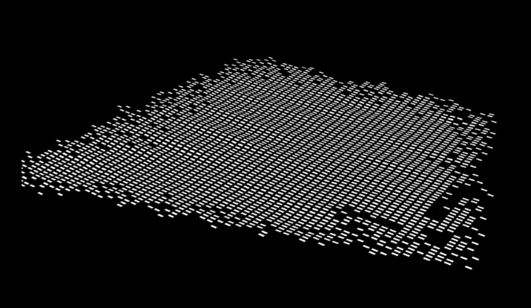

**Fig 9.** Concept diagram for Berlin Holocaust Memorial, distribution of basic pattern between two topological surfaces. [image] Available at: http://www. eisenmanarchitects.com/berlin-memorial.html [Accessed 5 Jan. 2017].

Eisenman covertly indicated to structure of the employed algorithm in this project, where he distinguished two grids in the site, one real and the other virtual; and through occupying series of horizontal vectors, he tried to "distort the structure of relationship between the two". As he explained, they allowed "the two grids to interact with one another and create an internal vortex of space." (Eisenman and Koolhaas, 2010, p.9) The basic pattern of the occupied algorithm is a concrete pillar of 95 centimeters in width and 2,375 meters in length, which subjected to a process of 2711 repetitions. Although the distributional path of the employed algorithm is linear, the determination of height of each pillar in every repetition has been assigned in accord with curvilinear topological order.

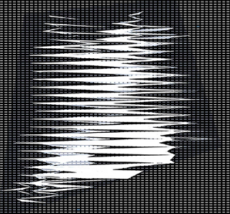

**Fig 10.** Concept diagram for Berlin Holocaust Memorial, employment of horizontal vectors as linear distributional path of algorithm. [image] Available at: http://www. eisenmanarchitects.com/berlin-memorial.html [Accessed 5 Jan. 2017].

1. **Conclusion**

The Advent of field theory, namely Einstainian proposed idea of the field, substantially changed the notion of space. It revealed the significant role of empty space as dynamic field of forces in the universe. The demanded characteristics of field condition in architecture as essential spatial feature which can be derived from this alteration, is first, subversion of monolithic form on the side of relationship between objects, and second, accentuation on role of the void as interrelationship between formal elements.

This study through analytical comparison between three cases came up with two certain strategies which are potential to provide field condition in architecture. That is, Twice and Algorithmic Repetitive Pattern. Through employing the Twice, the role of in-between space will be accentuated, but it is not necessarily give rise to subverting the monolithic form. As it was elaborated in Nara Convention Hall, through occupation of Twice strategy, the main space of the hall is a void as the interaction between two systems of fold, but since the exterior envelope of the project is generated by one of these folds, the building can be considered as a monolithic figural form.

On the other side, Algorithmic Repetitive Pattern is capable to subvert the monolithic form in favour of relationship between a number of repetitive modules. Yet occupying this strategy is not perforce result in stressing role of the void. That is, accentuation of void is depend on internal logic of the algorithm which dominated repetition process. As it was depicted in Serpentine Pavilion, employment of this strategy generated the fluid flexible structure which by no means can be recognized as the figural monolithic form.

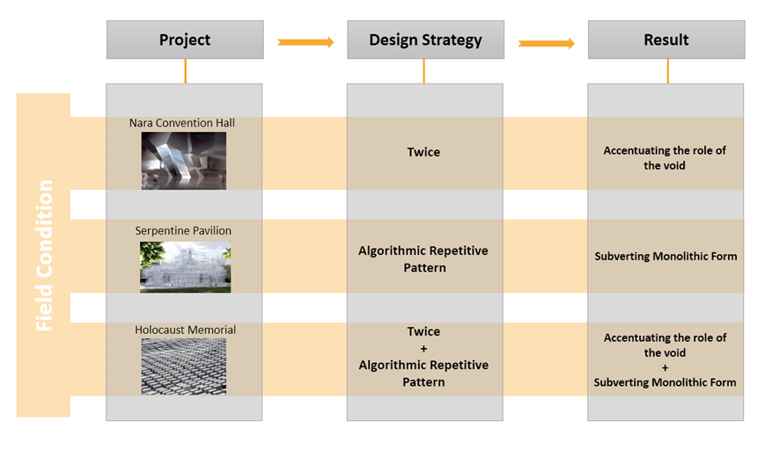

**Fig 11.** Two design strategies potential to provide field condition in architecture. (Developed by authors)

Although each of these strategies are potential to provide field condition in architecture, yet when they are incorporated with each other in a proper manner, like the way Eisenman did in the Holocaust Memorial in Berlin, then consequent spatial characteristic will be precisely in line with the field condition. While Algorithmic Repetitive Pattern subverts the monolithic form on the side of relationship between sizable number of modules, Twice stresses on the in-between space, namely the void between solids.

In view of the prevalence occupation of inventive design strategies in architecture during recent decades, indubitably there are other certain strategies which are capable to provide field condition, namely subversion of monolithic form and accentuation of void. Accordingly, this study can be considered as a guideline which set the stage for future researches. The enhancement of knowledge about design strategies will contribute to advancement of architecture both in theory and practice.

**Acknowledgement**

The authors would like to express their gratitude to Tarbiat Modares Unviersity, department of architecture’s academic staff for providing instructive atmosphere and also appreciate their kindly support.

**References**

Allen, S. (1997). From Object to Field. *Architecture After Geometry: Architectural Design Profile 127*, 67(5/6), pp. 24-31.

Ansari, I. and Eisenman, P. (2013). *Eisenman’s Evolution: Architecture, Syntax, and New Subjectivity*. Available at: http://www.architectural review.com/archive/interview-peter-eisenman/8646893.fullarticle [Accessed 29 May. 2017]

Corbo, S. (2014). *From Formalism to Weak Form: The Architecture and Philosophy of Peter Eisenman.* Burlington: Ashgate Publishing.

Cros, S., and Gausa, M. (2003). *The Metapolis dictionary of advanced architecture: City, technology and society in the information age*. Barcelona: Actar.

Davies, P. C. (1986). *The forces of nature.* 2nd ed. Cambridge: Cambridge University Press.

Eisenman, P. (1971). From Object to Relationship II: Casa Giuliani Frigerio: Giuseppe Terragni Casa Del Fascio. [online] Volume 13/14, p. 36-65. Available at: http://www.jstor.org/stable/1566970 [Accessed 26 June. 2017].

Eisenman, P. (2005). *Holocaust memorial Berlin*. Zurich: Lars Müller.

Eisenman, P., and Koolhaas, R. (2010). *Supercritical* (B. Steele, Ed.). London: AA Publications.

Greene, B. (2004). *The fabric of the cosmos: space, time, and the texture of reality*. New York: Alfred A. Knopf*.*

Greene, B. (2011). *The Fabric of the Cosmos: What is Space?* [video]. Available at: http://www.pbs.org/wgbh/nova/physics/fabric-of-cosmos.html [Accessed 12 Jan. 2018].

Kipnis, J. (2013). Towards a New Architecture. In: *A Question of Qualities: Essays in Architecture (Writing Architecture).* New York: The MIT Press, pp. 287-320.

Kwinter, S. (1986). ‘La Citta Nuova: Modernity & Continuity’. In: K.M. Hays, Ed., *Architecture theory since 1968.* Cambridge, Mass: The MIT Press, pp. 586-612.

McMullin, E. (2002). The Origins of the Field Concept in Physics. *Physics in perspectives,* [online] Volume 4(1), pp. 13-39. Available at: https://link.springer.com/content/pdf/10.1007%2Fs00016-002-8357-5.pdf [Accessed 20 Jan. 2017].

Portilla, D. (2013). *Serpentine Pavilion / Sou Fujimoto.* [online] archdaily.com. Available at: http://www.archdaily.com/384289/serpentine-pavilion-sou-fujimoto [Accessed 27 May. 2017].

Quintal, B. (2013). *Serpentine Gallery Pavilion 2013 / Sou Fujimoto.* Available at: http://www.archdaily.com/382871/2013-serpentine-gallery-pavilion-sou-fujimoto [Accessed 29 May. 2017].

Shirdel, B. (1993). Nara Convention Hall. *Folding in Architecture: Architectural Design Profile 102*, pp. 51-55.

Terzidis, K. (2006). *Algorithmic Architecture*. Abingdon: Routledge.