Dublin: New skin for who
Marcello Scalzo¹, *Alessandro Spennato¹,
Simone Zurli¹, Valeria Congedo¹
- University of Florence - Department of Architecture DIDA
*Corresponding Author: alessandro.spennato@unifi.it

Abstract

The renewal of Gran Canal Dock is an important moment for Dublin, an actual change of skin, where the architectural design wishes to be the bastion and the symbol of the renaissance of the city.
It represents the highest moment of “the Celtic tiger era”, when Dublin shows the ability to get out from a dark period, characterized by high unemployment level. The inner city urban fabric was full of a wide phenomenon of alcoholism, poverty, drug addiction, and social exclusion.
The establishment of private authorities, in substitution to traditional administration system of urban space by local government, it tries to operate to re-development of field through the intervention of private investors.
That way permits the aperture of a new season masterplan, and a new era for Dublin and entire Ireland, with a great opportunity for the city and its citizens. The planning of renewal concerns in the “Greatest Dublin Area” renovation, but mainly in the inner city and its fields, where the main aims are the social inclusion as EU directives, and a new face of urban fabric that represents a real change of these districts.
The Docklands renewal is the most emblematic example, that started with the Custom House intervention enterprises zone (CHDDA) and then turn to the other Dublin Docklands Development Authority (DDDA).
The KPMG report of 1996 has been an important reference for the achievement goals of social inclusion and urban mix, there is a willingness, of course in parallel way to create a new area with new landmarks which may be a beacon to the entire city.
They have engaged the most important architects to create a new great design of architecture there, but Gran Canal Dock gentrify does not represent a place for the real necessity of citizens, now.

Keywords:

Dublin Docklands, Social inclusion, Gentrification, Architectural design

Introduction

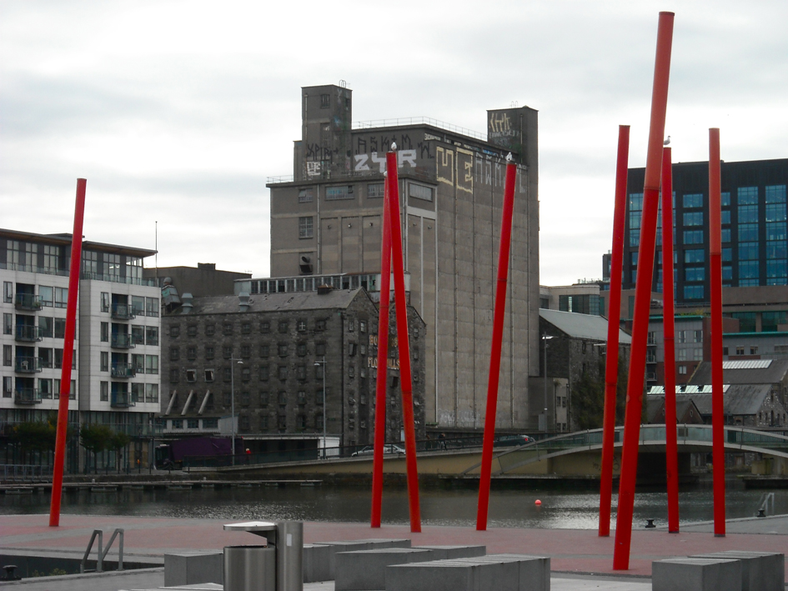
Fig. 1 - Gran Canal Docks and the Bolland’s Mill, source: Simone Zurli

The renewal of Dublin is considered one of the most and emblematic transformation after decades, the role of architecture has been to change the whole Docklands area in a still ongoing process.
The first problem of this district is the social exclusion, due to termination of industrial activities on the site, that problem is indicated as an emergency in KPMG report on 1996, where they foresee actions to combat the poverty, that it is an important factor in Dublin during the 90’s able to establish a particular type of community, given that the city is the fulcrum of the large portion of the nation (Redmond, Crossa, Moore, Williams, 2007).
The government implements some process of urban renewal to combat the high level of unemployment, by private Authorities that operate in various parts of Dublin, and it planned some projects called Mark with focus to the inner city renaissance, but also in some districts of the Greater Dublin Area (Bartley, Treadwell, Creamer, 1999).
In this paper the scholars analyzed the case study of Gran Canal Docks, as a European exemplar of process of brownfields regeneration, but an «urban and economic restructuring» (Moore-Cherry, Vinci, 2012) too, which it changed completely the society inside the Docklands.
The first pilot intervention for docklands renewal was the project for the Custom house on 1986, called Mark 1 (CHDDA), that it was effected by means of “Urban Renewal Act” on the UK and American models.
Unfortunately, the CHDDA creates a negative impacts and a risk of social polarization (Bartley, Treadwell, Creamer, 1999), thus it stimulates a reaction to urban regeneration policy, one of this is the financial incentives and the Corporation Tax Rate, a particular «Irish twist to the UDC (Urban Renewal Act) approach» (Sharry 1999).
The Mark 1 evolved in Mark 4 during the years, and so it transforms in the DDDA (Dublin Docklands Authority), that pursuing the KPMG principles and goals.
The main lines that the DDDA referred to built its masterplan are those in the IAPs project (Integrated Area Plans) for Inner City.
The interventions in that area try to follow the main objectives of masterplan for Docklands and Northlotts, as the urban regeneration policy uses in IAPs requirements to achieve its objective through a stakeholder approach for the renewal of fields (Bartley, Treadwell, Creamer, 1999).
On 1997, the DDDA produced the first masterplan for the Docklands area and extends the renewal process from the Custom House (Mark 1) to the entire area along the banks of the Liffey river and the Dodder river (Mark 4).
Bartley, Treadwell, Creamer writes in its paper on 1999, that the masterplan of Docklands try to include the proposal for social inclusion for a holistic regeneration, in fact it incorporates a «Consultative Council on which local communities» (Bartley, Treadwell, Creamer, 1999).
Unfortunately, the DDDA willingness to act in parallel to built a new area with a dual soul, of high finance of the one hand, and an inclusive citizens area in the other hand, it cannot to stern the strong speculative interests, that such change of urban fabric can lead.
The problem leads the real estate market speculation in Dublin interventions, to the property bubble and ghost estate until its crack during the big crisis on 2008, the aftermath and the discomfort of gentrification can be seen after decades.
The first purposes were not able to contain the failure to create inclusion, and new community, thus the new design is only for investors and new metropolitan businessmen, which they inclined for an elitist district that actually operates for the market policy.
The phenomenon takes place when the market succeeds on the regeneration process, the goals of field renewal falls down at the time that there is the change of design, in order to create recognizable areas with luxury houses and elegant building.
The worrying gentrification process, full of beautiful districts and landmark of high design actually are desert of architecture, as if the town were covered with an inaccessible bell jar (figure 2).

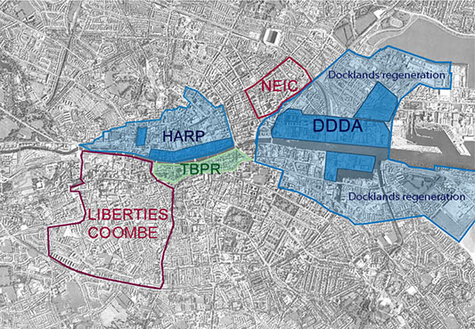
Fig. 2 – Programmes of interventions in the Inner City
Source: Simone Zurli

Case study Gran Canal Dock

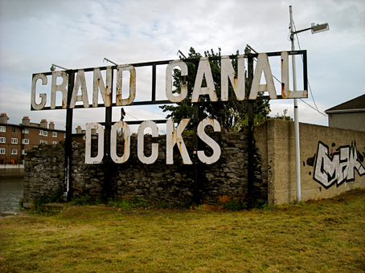
Figure. 3 - Gran Canal Docks, source: Simone Zurli

The architectonical renewals must be thought to present days to improve welfare and social inclusion, in addition to providing business plans to respond to their intervention in the medium and long terms, this is exactly the way recommended by EU directives dealing with urban fabric renovation.
In the Irish capital a process of territorial and social change is taking place since the end of the 90’s, the phenomenon is happening through the progressive changeover of ancient urban fabric; this is one of the most interesting intervention in Europe, after Berlin post-wall, and London City Tames Docks.
The renaissance of Dublin started in the 1987, when the Government established the UDC (Urban Renewal Act) setting up an economical development for the whole nation, to counteract the deep economical crisis and backwardness of the country.
The geographic conformation and high density of EIRE shall ensure that the decentralized capital of Dublin is one of the points of attraction of the entire State, and both Greater Dublin Area represents the heart of a nation with its 1,9 million of inhabitants according of CSO (Central Statistic Office).
Dublin has been heavily influenced by the Anglo-Saxon culture, and tries, through its liberal policy to improve its economic issues and treats the social ones, with their results. The policy promotes the urban governance, which are based even in the voluntary activities to improve quality of life, all of this is possible by keeping a technology avant-garde.
The real shift occurred in 2000, when the Dublin Development Board promotes some strategies of 10 years for development of the Town, they allow the active involvement of citizens through workshops, meetings and by focusing on some interesting areas for projects for social environment renewal to facilitate the social inclusion.
They realized a development plan on May 2002, and it was an instrument to estimate the amount of work and programmes for Dublin city, a guide for sustainable development until 2012 in order to create and after maintaining self-reliant districts based on the participate structure as Ballymun.
On that areas, where the architecture and society are degraded and deprived, were applied the bottom up concepts for the maintenance of cultural identity.
The private citizens, ONG no profit, Public bodies and Private Holding did a sort of concertation, since the Celtic Tiger started, all of this to ensure their goals about city improvement realized.
The taskforce group created contributes to a research which aims to do best use of own resources, using the participation of the interested population to execute the executive plans useful to satisfy the detected required, especially in the fixed gap time.
The real development beginning on 1997 with the establishment of DDDA (Dublin Docklands Development Authority), which with an act inherits all of the functions of the previous authority of the Custom House Docks Area, it has the assignment to draw up one of a giant masterplan of Europe of about 526 hectares (Moore Cherry, Vinci 2012). It was an ambitious project for the old warehouses renewal, aimed to become the symbol of the new Dublin.
On the North Lotts Area the old workers house in Georgian style were gradually replaced, and the original urban fabric changed completely, this gave to areas like Spencer Docks and Grand Canal Docks a completely new skin.

Development of the area
The Dublin dock harbour dates back to the 18th century, when intense industrial activities developed along the north and south banks of the river Liffey. The Saint Patrick church began to be a focal point for the area and its surroundings, which formed a real community.
The Grand Canal Docks and the Docklands formed the first part of industrial expansion of the town, built during the south growth between 1717 and 1727 later on the construction of a wall (identifiable on the toponymy of the place) of half a mile of length, that goes from the city center to the confluence of Dodder river with Liffey river.
The costruction works were financed by Sir John Rogerson, while the realization of Southlotts dates back to 1760, it extended its borders, including the internal basins that occupied a L strip of land, of 3 hectares of the area.
In 1796 the establishments were in operation and the administration of City Council, offered subsidies to promote commercial activities inside the area, the operation had little success due to the distance from the city center, the area’s industrial vocation, and the high level of deprivation of that district.
The lake of success of the Docklands districts was also due to a collapse where the two rivers converge to each other, with a consequent retraction of the mouth of the Dodder and the difficulty to use it as a navigable canal and as an external gateway to the Liffey.
In 1918 the Gas company took charge of the area cooperating with others Charcoal companies like Heitons, that took the dry docks for rent. The quay zones were used during the time as production factories, like sugar, bottles, flour production, and fertilizer.
The Docklands area was characterized for its widespread poverty, the high level of illiteracy, unemployment and social exclusion, until it became one of the most derelict place of the city with the highest dope addiction level during the 1980’s (Redmond, Crossa, Moore, Williams, 2007).
The end of the British rule was part of the problem of closure of the harbor activities and of its consequent disposal, this leaded to the slow shutdown of the area and a widespread of decadence.
The industries on the Docklands progressively left their own sites in order to relocate their companies, this abandon leaded to a progressive scattering of work activities, and a general decline of Dublin city during the 1970’s and the 1980’s.
If the north of the Docklands was mainly residential, the south was reserved for factories, but especially the site is aimed to be the passage of the rail useful for cargo movements (Moore-Cheery, Vinci 2012).
Between 1975 and 1984 an abandon from the inner-city districts towards the residential suburbs of Dublin took place, that leaded the city to take a shape of a circle, where the majority of the wealthy population lived on the border and the poor citizens were inside the city centre and in the Docklands area too.
The GCD renewal intention was to create a project inspired by the old structures of the English harbour, especially following the example of Birmingham where they create a new connection with the old city to re-establish the entire urban asset.

Analysis of the area

On November 1998, the DDDA commissioned to Antony Reddy Associates the Hamilton Hosborne King urban renewal project, to set the new structure of the plan of GCD.
The turning point came in 2000 by a local environmental Ministry decision, that gave a lot of power to the Authority to propose actions to define the future of the area.
The consideration made during the research path, and materialized in real actions to re-defined GCD identified:
- The development of the proposal and its origin;
- The destinations of use;
- The significant design that identify the new area as symbol of the renaissance of the city;
- The new design as symbol of the rehabilitation, that takes account of the real nature of the area, and of its own cultural heritage and its pre-existences.
- The requirement of an increasing plan of infrastructures and parking.
The policies introduced for the renewal referred to the indication of the goals of masterplan for Dublin 1997, of Dublin city development 1999, and of GCD action plan.
The masterplan 1997 described the future indications of GCD 2003, and it gave great importance to the canal basin, especially looking at water like a primarily architectonical element, in addition to the connection with the inner-city, and the analysis on the environmental impact for future decontamination.
One of the main future objectives of the masterplan is the Grand Canal Corridor project (figure 4), still under construction nowadays, that was commissioned by the Department of Art and Culture, with the intention to create a sort of integrated urban environment with the rest of the city and the whole Dublin’s society.
The study for the Corridor contained the promotion to social inclusion, trough several activities on site which include the citizen’s participation, such as the creation of a new theatre, the cohesion between people its behaviours, and new commercial activities.
The water element of two basins is the most important component to promote with no doubt, they must absolutely communicate each other, and preserve the old brownfield memory in all ways, basically to be the important role of link from the outer city to inner city and vice versa.

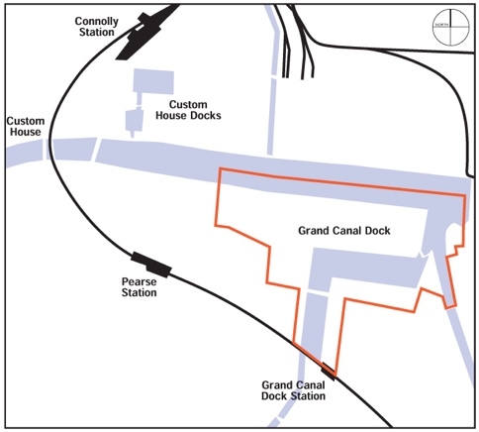 | 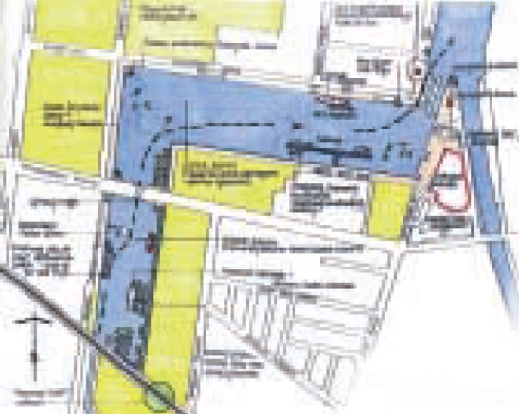
Figure. 4 - Gran Canal Corridor, source: Dublin City Development Plan 2016-2022

The division of intervention zones

The area of GCD consists in a wide portion of 29,2 hectares and 9 hectares of water of interior basin of the dodder river, and that of Liffey river basin surface.
The key point of Authority analysis satisfied the parameters for high housing density, according to the residential directives of 1999 for brownfield renewal.
The area is located in the South, and is strategically located in connection with the inner city and in proximity to the mouth of Liffey river, thus the first proposal of the plan was the new station of DARTE; the light rail station that connect the village of the Greater Dublin Area along the bay, from Howth to Greystones.
In the development plan GCD was divided in three macro-lots on, respectively: Grand Canal Square, Britain Quay, and Boland’s Mills. 9 intervention zones were detected within these macro-lots and for each of these zones structures to be preserved were selected and destined to the new use. in the following are summarized the intervention for each area, that they have been completed now.
Zone 1- This is the area of old warehouses and the historical pubs to preserve, it is located in Sir Rogerson Quay and Samuel Cardiff Lane. It is as mix of professional and old restored structures now, there are commercial activities and business offices in those buildings.
Zone 2- It has been converted in administrative area. In this site, where the gas company and the brick factory Kilsaran used to be long time ago, there are now administrative offices and residential buildings. The majority of them has an internal courtyard, and there is an old furnace in one of those. This compart is one of the most important of the entire renewal project, because it is ending in the main square where are located two of the important horizontal landmark of the whole basin: the theatre designed by Daniel Libeskind and the Gran Canal Square.
Zone 3- It is like a bridge among the Z.1 and Z.2, and it was characterized of old warehouses, restored now, there is a lot of shops in that area which is identifiable between Sir Rogerson Quay, Hannover Quay and Benson Street.
Zone 4- This area is one of the most analysed of the entire zone and it is now completely occupied by new buildings. There is an important document about its environmental impact study (EIS), in prevision to build the U2 Tower among the external basin of Liffey and the internal Dodder basin. The costruction of the Tower has been temporary stopped, one of the problem was the excessive height.
The Z.4 is located between Sir Rogerson Quay, Benson Street, East Green Street on the junction basin among the two rivers (figure 5).

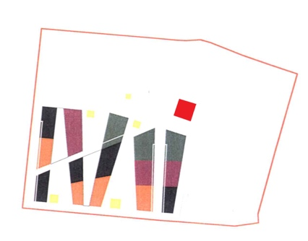 | 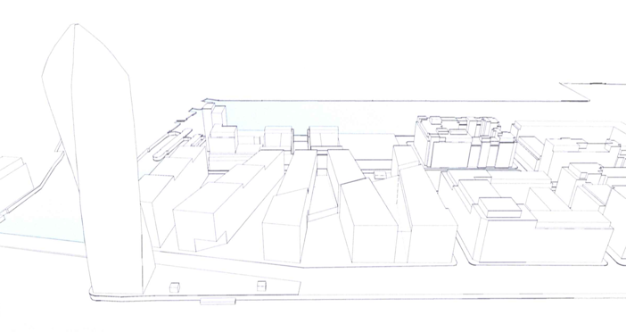
Figure. 5 – U2 Tower, vertical Landmark no built, source: Environmental Impact Statement Addendum detail

Zone 5- There are old warehouses to preserve here, the area is at the end of the junction basin, and Benson Street, East Green Street, Hanover Quay. The destination of use is a mix of commercial and housing.
Zone 6- This compart is opposite to Hanover Quay, and it looks out to the inner basin Charlotte Quay and on Ringsend Road, that area is mainly residential and there is a new vertical landmark as the Millennium Tower Building.
Zone 7- It is one of the most iconic of the area, especially for the presence of old Bolland Mills until 2015, unfortunately demolished for its poor state of repair, and substitute for another structure as a luxury Hotel.
It is to considered to be a regrettable fact the loss of this memory, because is what it was a deletion of one of the major vertical landmark.
The borders of the new building are identified in the old dock-mills in Victoria Bridge, Ringsend Road, and Barrow Street.
Other two landmarks are in the area on pursuing Barrow Street, the first is the Google tower, and the second is the horizontal focal point as DARTE rail train GCD station.
Zone 8- This zone is located among the Liffey and Dodder confluence, and it is connected with little pedestrian bridge with the rest of GCD, the Authority is the owner of that place, and therefore is designed as an open space for public functions. There is an old shipwreck in front of it, and it considered as a low landmark of the entire compart that balance the other two landmarks as new theatre and Gran Canal Square.
Zone 9- There are the Rowling club here, and residential buildings, its position is on the east side of the Liffey and Dodder connection, the restore through new housing concerns only the external place, while the area of Ringsend & Irish Community is remained unchained.
The subdivision areas above mentioned highlight the importance to enhance The Grand Canal Corridor in the masterplan, all of this for design requirements and market demands.
The GCD characteristic is to have a L shape formed by the two inner basin of the Grand Canal, and the masterplan foresees a building design that reflects the water element as much as possible (figure 6).

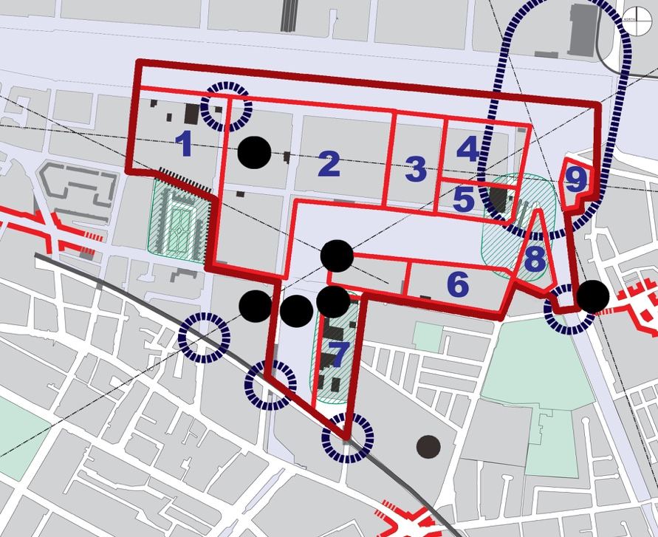
Figure. 6 - Gran Canal Dock sectors, source: Gran Canal Dock plan.

Urban analysis

The urban context of GCD has always been different then the rest of the city, as a result of its industrial characteristic. Therefore, the new costruction are included as they were an “independent citadel”, where the contrast with worker architecture of Pearse Street, Barrow Street, Ringsend Road is highly visible.
Three independent areas on the plan of GCD were identified, as Pearse square, the basin’s connection and space of Bolland’s Mill (now demolished); each of them have a fundamental role, although they are outer of their area of expertise.
They are the focal points inside the plan, that may be call “gateway”, and each of them is a representative element.
- Samuel Beckett Bridge (Calatrava’s Bridge);
- Victoria Bridge, among Pearse Street and Ringsend Street where the skyscraper “Alto vetro” is located;
- Crossroads between Pearse Street and Street Bridge;
- Barrow Street and Ringsend Road;
- Connection bridge among Hannover Quay and Gran Canal Street Upper.
The plan intention is to prefer building that are not excessively high as the balance and the harmony of the design is identified by two landmarks.
Some representative buildings represent the visual reference on the area, each of them are old and new constructions, and they are horizontal and vertical landmarks.
The vertical landmarks are high and are situated in the enterprises zone and on its borders. They think these elements not only for citizens, which identified them such as own memory of that zone, but GCD is a site where the future user might be to perceive them, as some elements of new memory is own of their place itself.
The old vertical structures are identified like triangle that fits among two canals and the urban context, that depart the Bolland’s Mill on the second basin, to then pass to the old furnace’s chimney and the old Gas company on the side of Liffey, to conclude at the end to St. Patrick Church Ringsend bell tower, towards the Ballsbridge area.
The vertical landmark of new constructions is identified like three tower that centred the two basins, the first three towers are built on the second basin and they are the Google Tower, but there is another Big tower in the opposite side, that consent an ideal visual cone with another Tower always in the borders, it is “Alto Vetro” building by Shay Clay Architects bureau. There is the Millennium tower in the other basin, that permits an another visual connection with “Alto Vetro” and the opposite “U2 Tower”, which should have been the final landmark to close the vertical structures system in GCD.
They have been identified three important node of access in the area, through the urban analysis for GCD renewal, the importance of that building inside urban fabric is due to the fact that the old structures are restored.
The first node is the new station entrance in Pearse Street, the second is the old Gasometer converted in residential building located in Gran Canal Street Upper, Haddington Road, S. Lotts Road, and the third between Bridge Street and Fritzwilliam Street until the Ringsend library (figures 7-8).

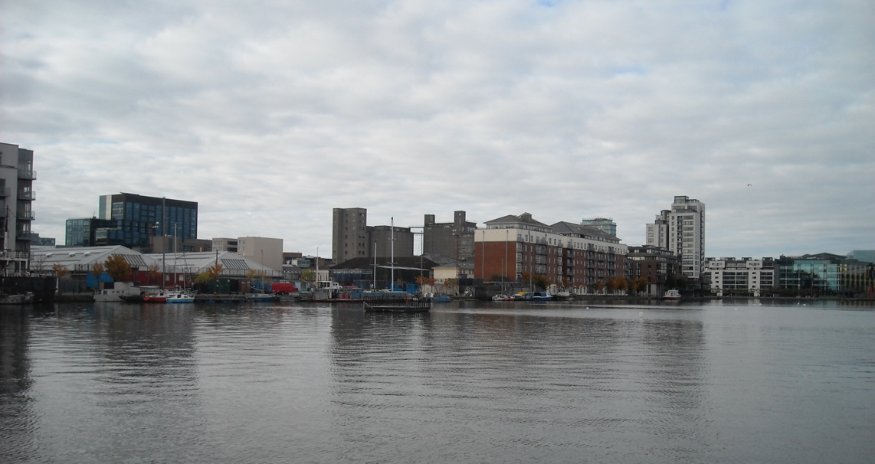
Fig. 7 – Vertical Landmarks, from right: Millennium Tower in Charlotte Quay,
Boland’s Mill (demolished in part) and Google Tower, source: Simone Zurli.

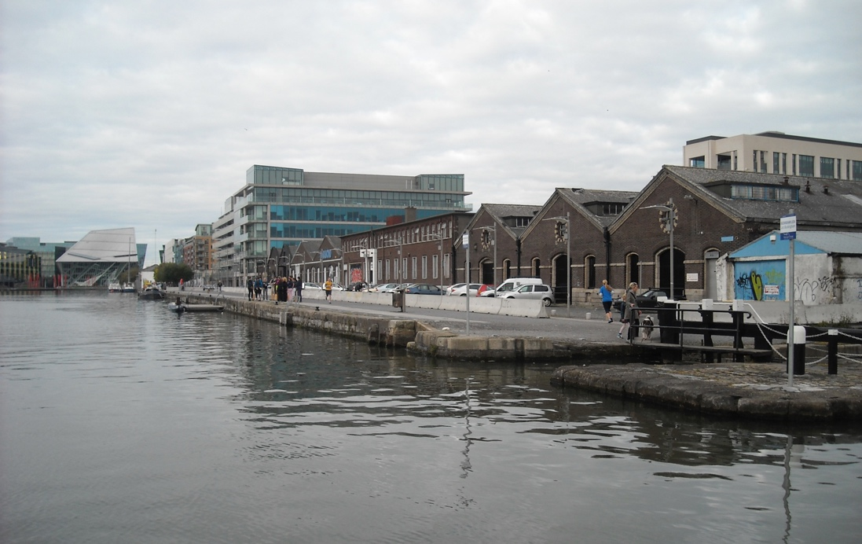
Fig. 8 – Horizontal Landmarks, Hannover Quay, Gran Canal Theatre, source: Simone Zurli.

Destination of use

The GCD destination of use has as objectives to build up an area with mix of population, thus there is a percentage of 40% of retailing (pharmacy, restaurants, shops) for 51,700 Sq.m. and 60% of housing equal to 370 units, there is a building with varied functions as housing and hotel and other polyvalent activities as cultural spaces, offices, and tertiary room.
There is a second hypothesis about the percentage of functions in the masterplan, 70% oh housing pairs to 432 units of dwelling, and a decrease of retailing in 30 % reducing that space to 46,100 Sq.m.
The third hypothesis considers a reversal regard to the first instead, considering 40% oh housing pairs to 247 units, and 60% of commercial spaces which includes 62,770 Sq.m.
One of the most important consideration of plan is to consider part of housing surface for administrative offices, aims to became the old docklands into a kind a “Irish City” able to convey many of international holding.

The offices are in general situated along the path of the two inner basins, and on the bank of the Liffey, so that they may have a better visual quality, and a major accessibility.
The surplus of squares meters is distributed in the building along Cardiff Lane, Macken Street, Hanover Street East, all of these on the Liffey river and nearby Gran Canal Dock Station, ant they are used to offices for professional activities, agencies, and big holding.
The diffusion of retail and little shop is very important at the beginning, to light the concentration in Pearse street, and promote the permeability of that zone, unfortunately houses and shops are very expensive nowadays, thus the GCD is one of the most gentrified area in town.

New Skin for architectural design and gentrification

The Authority provides for mix of functions in GCD to follow the indication of masterplan of 1997, focusing in particular for social function mix, with a varied family units made of single, young couples, families with children and pensioners.
The rural characteristic of the Ireland is always problems of native migration from the outer villages to the Capital, with result and an overvalued of housing market, that it has a significant increase during the last few years.
On the other hand the average of Irish active people income, do not manage to reach the buying power of the first house, despite being among the highest in the Europe.
The first goal for GCD is to provide at this necessity, according of these previsions, thus a quote of dwellings is destined for social housing. The quote of social housing is the same that of the Northlotts one, i.e. 20%, and its constructive parameters have to be equal to building governed by market rules.
The guide design turns towards simple building to guarantee a good quality of dwellings; they prefer fast costruction technique for a better comfortable living.
The project actions respond to GCD guidelines indication, and they preserved the costruction rules as the distance for the building, i.e. terraces, rooftop gardens, and internal courtyards.
The apartments for families and elderlies are inside the lots, while the luxury one are locate in the exterior side to allow the view to the water basins.
The reason of this choice is to avoid that the apartment to ground floor come into contact with the shop in the GCD core.
The structure of the lots takes up the structure of macro-lots of the blocks, and its road viability to maintenance a good road coherence adjustment, and an appropriate urban permeability.
The structure of the building follows the line of the old geometry road, and they constitute the close blocks with courtyard inside, and divided in the followings typology:
- The blocks situated on Liffey river, Macken Street, and Cardiff lane.
- The blocks along the two basins on Grand Canal, with elegant structures are preserved in order to give unicity of that place.
- The blocks on East West Street on the ex gas company site.
The big dimensions of the volumes allow to take up the urban fabric, and to host the mix of residential functions, commercials and professional activity.
The renewal of GCD represents the renaissance of Dublin, but the real start of that area is in 2009, when they opened the Samuel Beckett Bridge by Santiago Calatrava, the bridge and its form to lira is an architectonical contemporary symbol of the place.
Daniel Libeskind designed the Gran Canal Square Theatre instead, which was in 2010, it is characterized by dynamic volumes, thought like a sculpture that wants to communicate with the space around itself.
The square is considered like an “enormous stage” for the people urban relationships, thus the theatre assumes the function of new monument in that high business space, well the building is one of symbol of entire city renewal, known as “Silicon Docks”.
The square has been designed by Martha Schwarz, which created a sort of red carpet in resin and glass that joins by a diagonal verse the theatre and the Liffey river, it passes through a green flower beds where the tubular red lights are at the end, they are 8 meters high, and represent boat masts.
The light system has been designed by the English bureau by Speirs and Major, they fit in the red and green lights for the red carpet and green one, and the area takes inspiration of the old Irish marinas (figure 9).

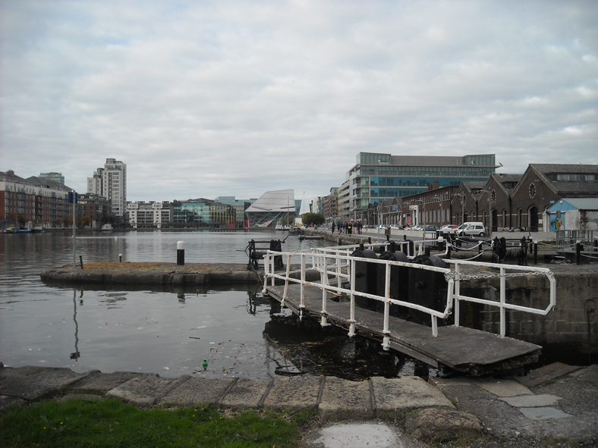
Fig. 9 –Gran Canal Theatre and Gran Canal Square in the bottom, source: Simone Zurli.

The architects want to create a new landmark with those elements, but the international crisis has stopped the blaze of the great project at the beginning of the new millennium, and therefore they didn’t realize the buildings from the most important archistars as Zaha Hadid and Norman Foster (i.e. U2 Tower), however those interventions would have cancelled the origin urban fabric.
The masterplan of Docklands and Northlotts has some goals, the infrastructural strengthening, the urban fabric renewal, the protection of field and its local community to promote the social inclusion, and the integration of old and new residents, natives and foreigners.
The methodological approach used for the masterplan can be resumed in accordance to the exigencies of damaged brownfield, and the development of touristic sector and commercial one, to facilitate the work activities and the location of the international holding.
The problem of the renewal is the gentrification and the increase of housing costs that create difficulties to people to buy a house in the Docklands area, moreover the international crisis and the high level of unemployment has created difficulties to mortgage access.
Thus the Docklands area and its surroundings have become exclusive zones for rich, where the middle class cannot access, and if the problem before was the social exclusion caused by the decadence; now the social exclusion is the luxury of the renewal.
The gentrification is not always a negative process, because it is the results of a renewal place, and the prices increase is a logical consequence, however it was forced by the big holdings, its businessmen and the commercial activities that rotate around them, all of these causes played a role in the abandonment of the area by the local people, starting a progressive “desertification” process.
The negative side of gentrification is often caused by the stakeholders, that overwhelm the local citizens. Theoretically the government has to do the interests of its populations, but sometimes it is slave of the market and its investors.
There are two aspects to understand in the gentrification process, the first is combat the poverty and the second is the architectonical and urban renewal. Two beautiful assumptions to support the social cohesion and create the stronger economies (Lees 2008), even its put into practice enhances the disaggregation and exclusion instead.
When the plan wants to create welfare for a particular area is a good thing for the local citizens, that can move the decadence away from their places, but the problem is that the evolution that leads the renewal, it is often a cause speculation, the prices increase, and a raise of value.
The speculation implies to live with a kind discomfort. This lack of satisfaction is not only for GCD, but it may be felt in the suburbs too.
The risk is a slow substitution of the local population by another, but foreigner and rich they don’t have interests in getting to know and live the area.
Two scholars of Davidson and Lees analysed the gentrification phenomenon during 2005, and they identified two requirements: the first is the capital reinvestment that leaded to the brownfield transform in grater business centre, according to the ordinary gentrification model (Smith 1992). The second requirement was the “Rent gap” theory, a kind of social reintegration and its consequent incoming of the new middle class or high class, to the detriment of less wealthy families.
The great holdings often transform the fields, and what is the prices for implementation job and luxury design? A new residential development surely, where it does not consider the resident local population, therefore the urban programmes must be the guardians against the speculative process that hide behind requalification projects.
Davidson and Lees studied in their report on 2005 the change of fields, where the new gentrified area and the reinvestment of its economical capital leads to the renaissance of new structures, that become new landmarks for citizens, tourists and business men. In the GCD case, the old warehouses increasingly tend to accommodate commercial functions and of entertainment too, all of this useful to community, but why? And how long? (Davidson and Lees 2005).
The problem of new GCD is not only move away the local people in other areas of the city, due to the high prices, but they created an inaccessible area for families with low and middle income, by growing the housing emergency without fulfilling the conditions of development plan, that the Local Government had planned like main goals.

Conclusions

The scholars in this papers have addressed the regeneration process of city od Dublin’s Docklands during the 90’s and the first decades of 2000’s.
They have evaluated the impact of this intervention long-distance of two decades, and the role of new architectural and urban design on the citizens, and the real evolution of the rest of the city.
In relation to the total interventions in the city, the case study focuses in the GCD area, that is a portion of Docklands fields, and its core zone too.
GCD in the most emblematic intervention on the Docklands area, end it represents the application to urban regeneration approach regard to social inclusion objectives to aid the disadvantage communities (Lloyd, McCarthy, Newlands, 1999).
They have analysed the entire context firstly, and the social system in the area before its renewal, characterized of high social exclusion, and unemployment which spreads in the inner city districts creates the typical circular effect. There was a social polarization in Dublin: the high class outside, and the low class inside, thus there is an effect with the population was allocated in the suburbs, while the city centre was empty of relationships.
The first area of interest for the renewal was the enterprises zone of Custom House, where they established the CHDDA authority on 1987, whereby they followed the UDC requests for regeneration of the city.
The CHDDA was transformed in DDDA on 1996, when they decided to extent the regeneration process in the entire Docklands area, until the mouth of Liffey river. They considered the results of KPMG report on 1996 for the masterplan and built the objectives, and also its economical report stipulated on 1999, regard to the fiscal incentives for urban housing and attracting foreing investors (Lloyd, McCarthy, Newlands, 1999).
The passage from CHDDA to DDDA begins of real change of skin of docklands Dublin’s area, and the first actions is the implementation of infrastructural network, to connect these fields with rest of city. The fundamental interventions are the tramway stop in Spencer Dock in the the North wall, and the Gran Canal Dock Dart Station in Barrow Street, furthermore they create of new landmarks to make the place more recognizable from all parts of the city.
The masterplan was very ambitious through the regeneration of over 526 ectares of land (Moore-Cherry, Vinci, 2012), and it is still ongoing to external areas to regenerate the entire Dublin harbour including Balls bridge and Stella Garden, where the Aviva Stadium is located.
The Gran Canal Dock area is one of the first emblematic intervention, they call the most important architects in the world for it, as Calatrava, Libeskind etc., in order to create a new urban context.
The problem of this great expansion actually is the quick changement of field, then kill of speculative real estate market, that proved very strong and able to lead the game of interventions.
The complication of regeneration is due from two elements: the first is the increase of housing market prices caused by the presence of the big international holdings in that field, the second the crack caused by the crisis of 2008.
Nevertheless, the city of Dublin has shown a great level of resilience, the construction of renewal started again and there is a new possibility for building remained skeleton after the crisis.
However, the high prices of real estate and the housing emergency fed by the mortgage access issue from middle class people, it still creates the phenomenon of ghost estate, a typical example of property bubble (Moore-Cherry, Vinci, 2012).
The typical present dwellers of Docklands are the metropolitan Businessmen, usually not permanent, who they are not interested to constitute a new community for the renaissance of field, thus the elegant architectures are nothing else than a new environment inside the city of Dublin, that very little reflects the citizens needs.
People are not able to live in the GCD area, and the communication of new architecture is completely different for the original goals, now is a tipical gentrify districts, where the residents are rich foreign people, tourists and students.
So, they have been disregarded the KPMG objectives for social inclusion, during these decades.
A new urban fabric thereby, a new skin, but actually for who?
Where there was exclusion they created an other form of exclusion, do not made by social degradation, but made of richness exclusion largely powered of new luxury and anonymous architectures.

References

AA.VV. (1991), London Docklands, Past Present and Future, Polytechnic of East London, London.

Bartley, Brian & Treadwell, Kasey. (2003) Competitive City: Governance and the changing Dynamics of Urban Regeneration in Dublin. In Moulaert, Frank. Rodriguez, Aratxa. & Swingedouw, Erik. (2003). The Globalized City, Economic Restructuring and Social Polarization in European Cities. Oxford University Press.

Davidson, Mark, Loretta, Lees (2005), New-build `gentrification' and London's riverside renaissance, available in Environment and planning Volume 37, DOI:10.1068/a3739, pp. 1165-1190 in https://wordpress.clarku.edu/, data of consultation: 16/12/2019.

Dublin City Development Board (2002), Dublin 2002-2012. A City of Possibilities, Dublin City Council.

Dublin Docklands Development Authority (2002), Docklands North Lotts, Dublin.

Dublin Docklands Development Authority (2000), Grand Canal Dock, Planning Scheme 2000, Dublin.

Dublin Docklands Development Authority (2008), Grand Canal Dock, Planning Scheme 2000, Dublin.

Dublin Docklands Area (2003), Masterplan 2003, Dublin Docklands Area, Dublin.

Dublin Port Company (2012), Masterplan 2012-2040, Dublin City Council.

Grand Canal Square, Dublin, Ireland (2008), disponibile al sito: http://www.frau1808.it/newsletter2008/, data of consultation: 16/12/2019.

KPMG (1996), Study on the Urban Renewal Scheme, Department of the Environment, Dublin.

Lloyd, Michael, Gregory & John, McCarthy,(1999), The case of Dublin Harp, Paper presented to the 39th Congress of the European Regional Science Association, Dublin, 23-27 August 1999.

Martinotti, Guido (1993), Metropoli. La nuova morfologia sociale della città, Il Mulino Saggi, Bologna.

Moore-Chery, Niamh (2008), Dublin Docklands Reinvented, Four Courts Press, Dublin.

Moore-Cherry, Niamh (2008) Dublin Docklands Reinvented: The Post-Industrial Regeneration of a European City Quarter, Dublin: Four Courts Press.

Moore-Cherry, Niamh, Vinci, Ignazio (2012), Urban regeneration and economic crisis: past development and future challenges in Dublin, Ireland, Planum the journal of urbanism N°.25 Vol 2/2012, available in http://www.planum.net, data of consultation: 07/01/2020.

Redmond, Declan, Crossa, Veronica, Moore, Niamh, Williams, Brendan (2007), Dublin as an emergent global gateway, pathways to creative and knowledge-based regions, ACRE Report 2.13, University of Amsterdam.

Sharry, Carmel (1999), Interview. Co-ordinator of Urban Renewal Schemes, Department of the Environment, Dublin.

Smith, Neils (1992), Blind man’s bluff, or, Hamnett’s philosophical individualism in search of gentrification, Trans. Inst. Br. Geogr. N.S. 17: 110-15.

Vicari Haddock, Serena (2004), La città contemporanea, Il Mulino Universale Paperback, Bologna.

KPMG (1996), Policy submission, this documents is a report where they provide to give directions and objective to prevent the poverty in Ireland. Documents available on www.combatpoverty.ie
Cf. Bartley B, Treadwell K, Creamer C. (1999), Table 2, evolution of housing and democratic accountability in models p. 347.
Ibidem p. 337.
Ibidem p. 338.
Cf. Central Statistic office of Dublin, data’s available on https://www.cso.ie/en/index.html.
Cf. Gran Canal Dock plan part 2. p.12.
Cf. Gran Canal Dock plan part 1 p. 5.
Ibidem part 2 p. 9.
Ibidem part 2 p. 10
Ididem.
Ibidem.
Ibidem.
Ibidem part.2 p. 11.
Ibidem.
Ibidem.
Ibidem.
Ibidem.
Ibidem p.14.
Ibidem p.15.
Ibidem.
Ibidem part 3. p. 23.
Ibidem part 4. p, 29.
Ibidem pp. 30-39.
Ibidem part 5. pp. 40-48.
The structure of Irish society is addressed on the book by Redmond, Cross, Moore, Williams (2007), “Dublin as an emergent global gateway, pathways to creative and knowledge-based regions”, pp. 31-52.
Through a public private partnership approach, the goal was to spend approximately £ 350 million (€ 444 million) of public funds to lever circa £ 1.25 billion (€ 1.59 billion) of private investment in the greater docklands area. Cf. Moore Cherry N. Vinci I. (2012), “Urban regeneration and economic crisis: past development and future challenges in Dublin, Ireland” articles in Planum. The journal of Urbanism n.25, vol. 2/2012 (II Semester 2012), available on www.planum.net.

